

**VIETTEL GROUP**

**IPCC CLOUD - MYCC**

**USER GUIDE**

**PROJECT: IPCC CLOUD**

**DOCUMENT:** USERGUIDE_IPCC_CLOUD_AgentWeb_v1.0

**Hanoi, 07/2019**

**CHANGES IN RECOGNITION**

*A – Create new, M – Modify, D – Delete

|  |  |  |  |  |  |  |
| --- | --- | --- | --- | --- | --- | --- |
| **Date** | **Position** | **A – M - D** | **Source** | **Old version** | **Change description** | **New version** |
| 05/07/2019 |  | A |  |  | Update | V1.0 |
|  |  |  |  |  |  |  |
|  |  |  |  |  |  |  |
|  |  |  |  |  |  |  |
|  |  |  |  |  |  |  |

**MỤC LỤC**

1 INTRODUCE 5

1.1 Document’s taget. 5

1.2 Definition of terms and abbreviations 5

1.3 References 5

2 USER GUIDE 6

2.1 Log in/Log out 6

2.1.1 Log in 6

2.1.2 Log out 10

2.2 MANAGE THE AGENT’S STATUS 11

2.2.1 Display status box 11

2.2.2 Agent self-changed status 13

2.2.3 The system change agent’s status to OFFLINE. 14

2.3 TICKET FEATURES. 15

2.3.1 The system automatically pops up a ticket when the agent receives an Inbound call 15

2.3.2 Display list of tickets 18

2.3.3 View Ticket 20

2.3.4 Update ticket 25

2.4 VOICE FEATURES 26

2.4.1 Voice Inbound features. 26

2.4.2 Voice Outbound features 41

2.5 CHAT FEATURES 45

2.5.1 Customers send chat requests 45

2.5.2 New chat notification 47

2.5.3 Receive/Reject a new chat 48

2.5.4 An agent does chat with a customer. 50

2.5.5 Agent hold chat 52

2.5.6 End a chat 53

2.6 EMAIL FEATURES 55

2.6.1 View content of customer's email 55

2.6.2 Reply email 56

2.6.3 Forward email 57

2.7 FACEBOOK FEATURES 57

2.7.1 View customer’s posts/comments 57

2.7.2 Respond to tickets from Facebook posts/comments 58

2.8 MONITORING FEATURES 58

2.8.1 Dashboard 58

2.8.2 Queue monitor 61

2.8.3 Agent monitor 63

2.8.4 Transaction monitor 64

2.8.5 Transaction support features 65

3 APPENDIX 69

3.1 Appendix 1: Notes when you login AgentWeb on first time. 69

3.2 Appendix 2: Actions need to be performed each time there is a new version. 70

# 

# INTRODUCE

## Document’s taget.

User guide of WebAgent to present the meaning, purpose of use, steps to perform user functions when using WebAgent module.

## Definition of terms and abbreviations

| **Terms** | **Abbreviations** | **Note** |
| --- | --- | --- |
| IPCC | Customer contact center based on IP |  |
| Agent | General use for both Consultants, Supervisors |  |
| TVV | Consultants/Agent |  |
| GSV | Supervisors |  |
| KH | Customer |  |
| TH | Case |  |
|  |  |  |

* Table : Terms and abbreviations.

## References

|  |  |  |  |
| --- | --- | --- | --- |
| Name of documents | Release date | Source | Notes |
| N/A |  |  |  |
|  |  |  |  |
|  |  |  |  |

Table 2: References

# USER GUIDE

## Log in/Log out

### Log in

* Description: user logins AGENTWEB module.
* Step 1: User fills URL to web-browser: (ex: [https://myccpublic.metfone.com.kh](https://myccpublic.metfone.com.kh/)) 🡪 click Enter.
* The system will show screen:

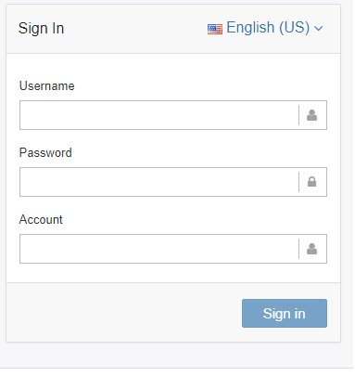

* Step 2: Enter User Name, Password, Account *(Administrator provides account for user)*
* Step 3: Click **“Sign in”** 
  + When you input valid username, valid password 🡪 the system will show screen:

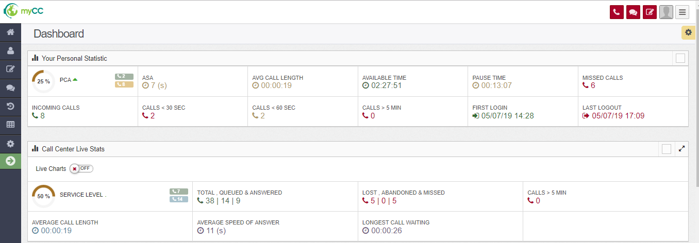

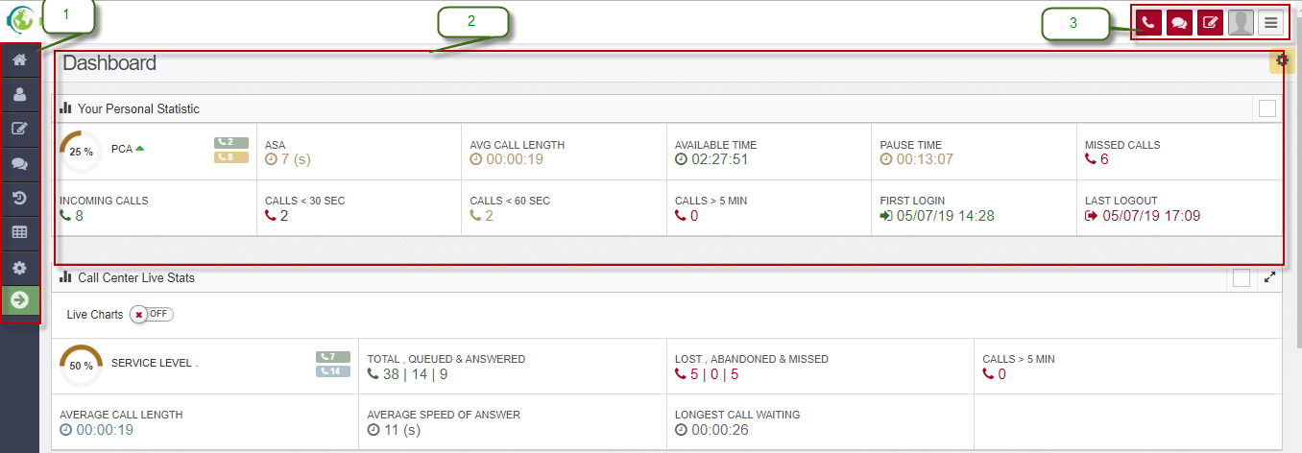

* Describe parts on the screen:
  + 1: Menu (Left)
  + 2: Dashboard: Detail information after you click any function on left menu.
  + 3: Scrollbar: Manage agent’s status và intergrate Webphone – allow user to receive call on web.
    - When config device for Agent: In checkbox WebRTC **have option** “Use webphone” 🡺 you click checkbox 🡪 the screen will show:

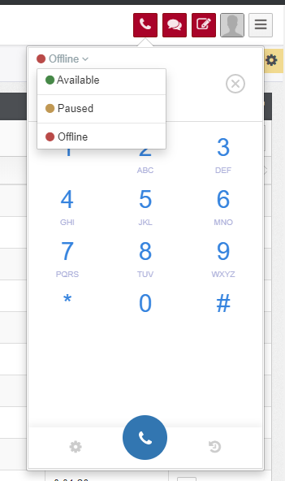

* + - When you do not click checkbox “Use webphone” 🡪 the screen will show:

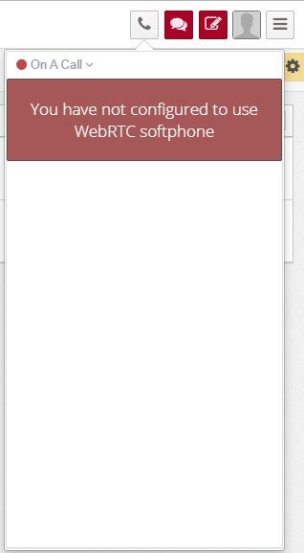

#### Agent log in multiple browsers / open multiple tabs / login again after losing connection

* With call, at the moment, **Webphone is valid only at 1 tab**.

o Web agent allows users to log in multiple browsers, or turn on multiple tabs at the same browser. However, at one point, Webphone is only valid at 1 tab (the call only drops to that tab)

o If the user is logged in, then continue to turn on another tab on the browser or log in another browser 🡪 The login tab will display an error message later: 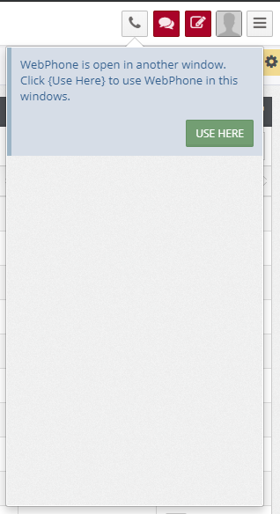

* + Users can click on "USE HERE" to push the old login session, and use call reception in the current tab.
  + In some cases, the Agent's computer loses its network and the system is not aware that, after logging in, the system is still understanding that the user is logged in, the user can also use the "FORCE RECONNECT" feature to Push the old login session to continue receiving the call

### Log out

* Description: For user to logout.
* Step 1: Click icon Agent  (at the to right of the screen) – choose **Logout.**

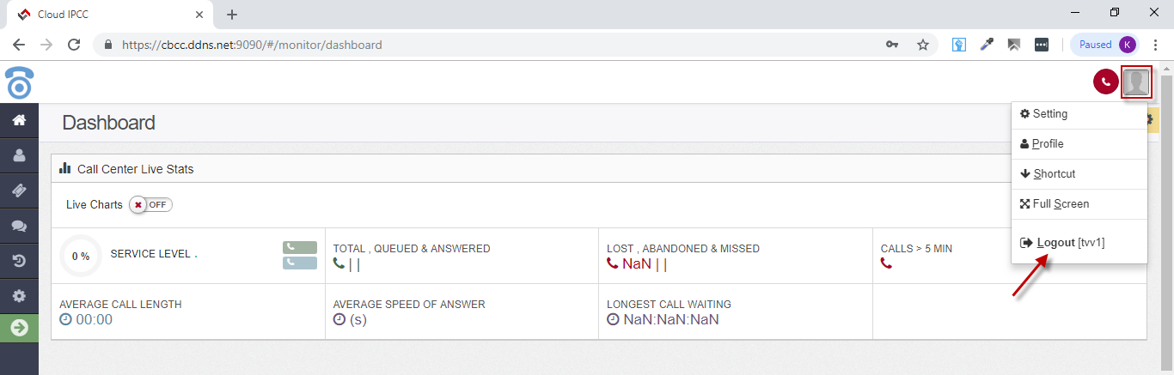

* The user is logged out of the Web Agent, returning to the login screen.

## MANAGE THE AGENT’S STATUS

### Display status box

- Description: Function to display user status on Web Agent. 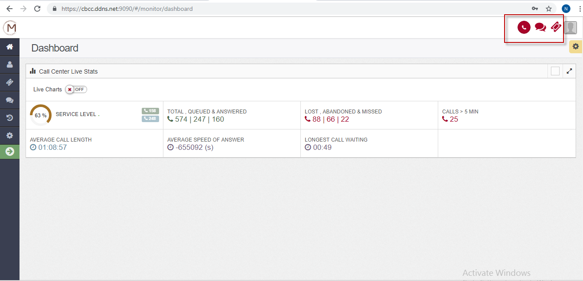

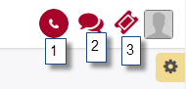

* + 1: phone’status icon
  + 2: chat’s status icon
  + 3: ticket’s status icon
  + VOICE STATUS: The user clicks on the icon phone on the scrollbar, the status box is displayed at the bottom.

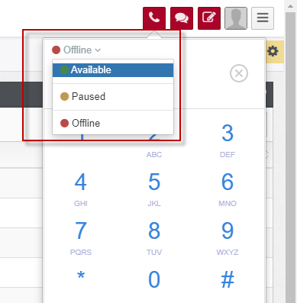

* + Available : ready to receive inbound call (The system distributed call auto)
  + Offline : logout of Queue, in this status: Agent does not receive the call of another Agent transferred.
  + Paused : the status is not ready to receive the call distributed, but still receive a call from the other tranfer to the Agent directly.
* CHAT STATUS: Users click on the chat status icon on the scrollbar, the status of the chat channel is displayed as follows:

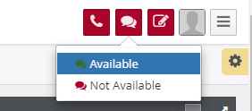

* + Available : ready to receive chat from customers.
  + Not Available : NOT ready to receive chat.
* TICKET STATUS: The user clicks on the status ticket icon on the scrollbar, the ticket status displays as follows:

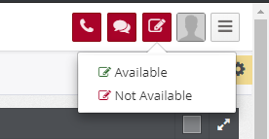

* + Available: ready to receive distributed ticket.
  + Not Available: NOT ready to receive ticket.

### Agent self-changed status

* Function that allows Agent to change his status. Includes: voice status, chat status, ticket status.
* Switch voice channel status: user clicks on phone icon, then select the value you want.
* Switch the chat channel status: users click on the chat status icon, then select the value you want.
* Transfer ticket status: user clicks on ticket icon status, then select the value you want.

### The system change agent’s status to OFFLINE.

- When Agent rejects the call 3 times, the system will automatically switch Agent's status to OFFLINE and display the Agent's notification as follows: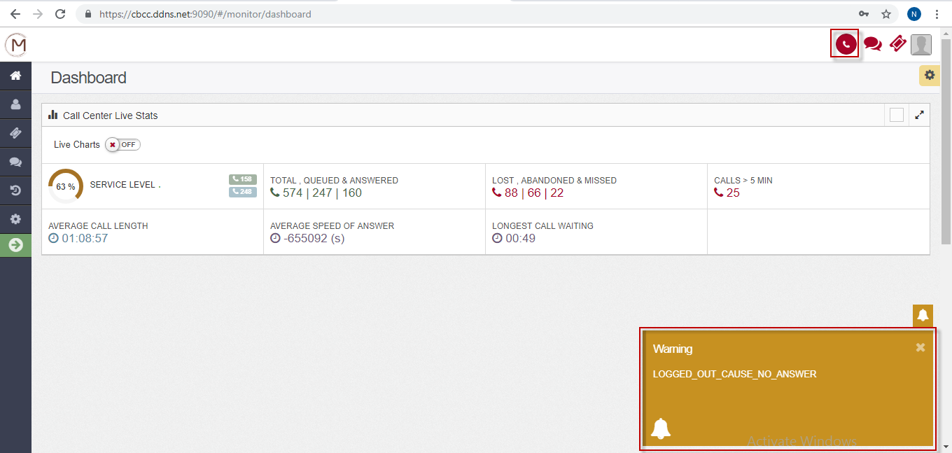

## TICKET FEATURES.

* For each transaction: Voice Inbound / Email / Facebook post / comment, the system will record 1 customer request. That request is called a ticket.
* With an inbound call: a Ticket is born with a call to Agent or no Agent. When Agent receives Inbound voice transaction, the system will automatically turn on the Ticket link.
* Email Transaction: a Ticket was born when customers sent email to the system
* Facebook post / comment transaction: a Ticket is generated when a customer posts (Depending on each fanpage that allows customers to post or not, usually only an admin can post on fanpage) or comment on fanpage.
* Note: Particularly for chat transactions (from the web, from facebook): currently the system has not yet generated tickets.
* About the distribution of email / facebook tickets to agent:

+ The system can distribute itself to a status-free ticket Agent

+ In case the ticket channel status of the agent is not available, the supervisor can manually assign to the agent.

### The system automatically pops up a ticket when the agent receives an Inbound call

* When the agent receives an inbound call, a ticket is popped up automatically as follow:

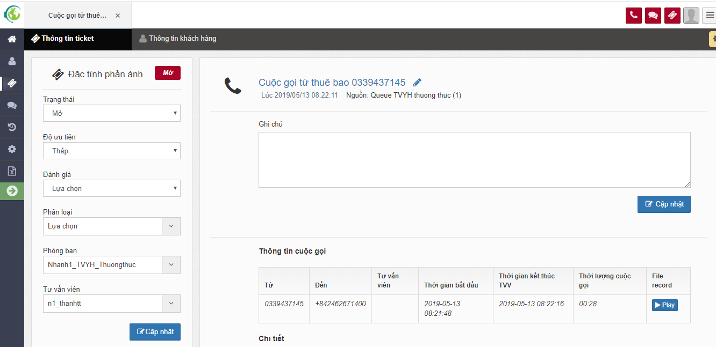

* **(1): Ticket’s information Tab: shows common information of a ticket.**
  + Includes:
    - Status:
      * Default value: Open
      * Options: Open, ReOpen, Closed, Temp Close.
    - Priority:
      * Default value: Low
      * Options: Low, Medium, High
    - Evaluate:
      * Default value: Select
      * Options: Select, Positive, Negative, Neutral
    - Department:
      * Default value: Agent's department is receiving.
      * Options: list departments of the company.
    - Agent:
      * Default value: Agent’s username is receiving.
      * Options: when choosing the department 🡺 List of Agents displayed by agents of the respective unit.
      * **An agent can assign tickets to another of the same or other units.**
    - Notes: The agent can enter processing content.
      * The agent can take notes many times. All notes are recorded.
      * With “Closed” ticket, the agent can not save notes.
      * The agent only saves Notes to the Ticket being assigned for himself.
  + The agent enters content when processing customer requests in the Comments box in the right pane.
  + The agent can change the properties in the left pane and then click Update to save the general information of Ticket
* **(2): Customer’s information Tab:** 
  + If it is the first time the customer calls to system 🡺 The system pops up the customer screen with only phone number, no other information as follows:

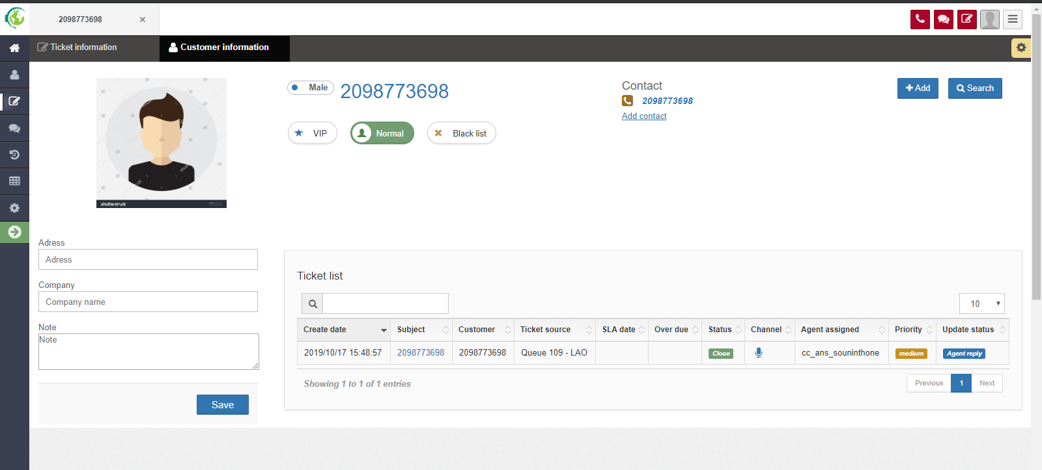

* + If the customer’s phone number already exists in the system -> The system pops up the customer information screen with that phone number:

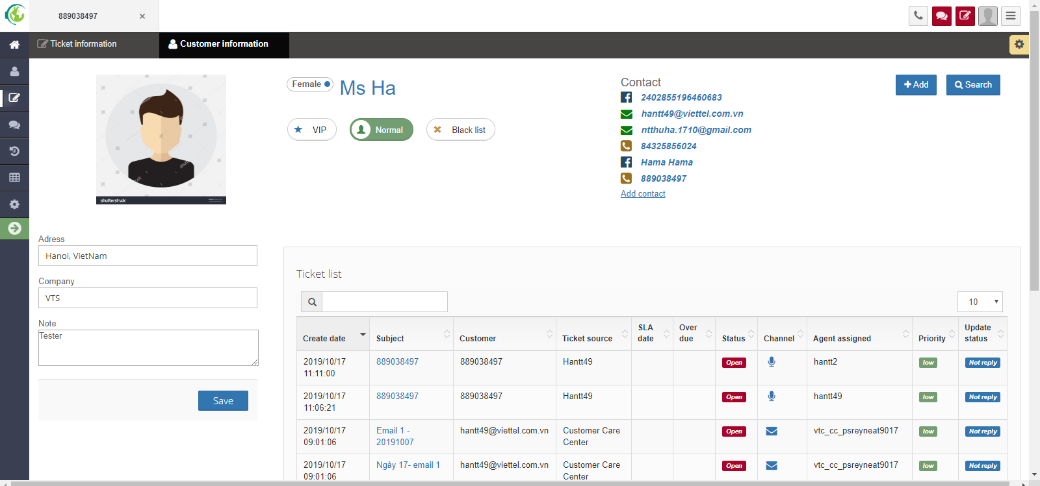

* + Users can enter customer information in the left pane (Red circled frame) and then click "Update" to record customer information.
  + Tickets list (right frame): displays the ticket history of the customer who has contacted the system.

### Display list of tickets

* The function shows the system's ticket list.
* Click “Ticket” menu , choose Ticket:

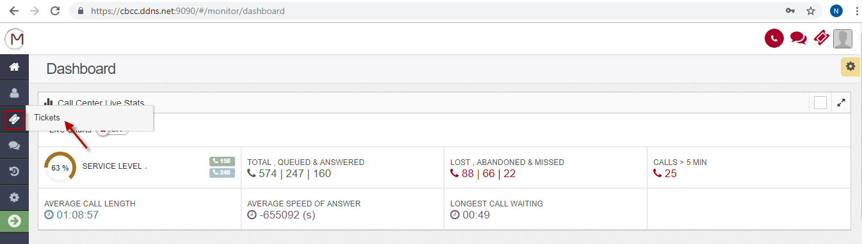

* The system shows as follow:

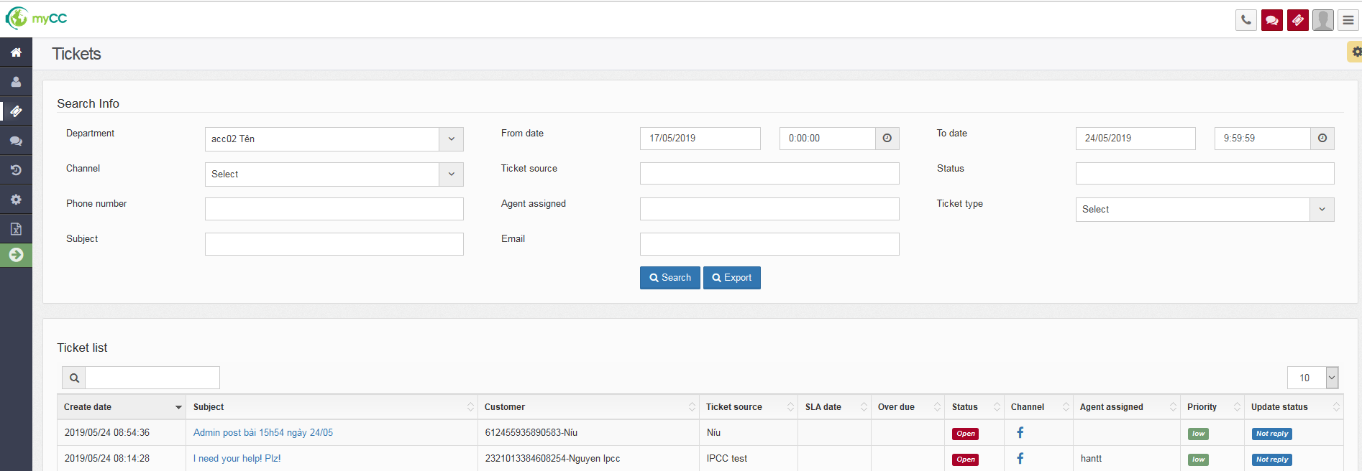

* Step 1: Users enter data for searching criterias:
  + Department (*): choose one value from list of enterprise and its sub-departments of the user who is logged in
  + From date, To date (*): format: dd/MM/YYYY hh24:mi:ss
  + Channel: choose one value: Voice or Email or Facebook. Default value: “Select”
  + Ticket source: choose values from list queues. If no value is selected, default search by all.
  + Status: choose values: Open, ReOpen, Closed, Temp Close. If no value is selected, default search by all.
  + Phone number: input text, allow relative search.
  + Agent assigned: input text, allows relative search, regardless of uppercase or lowercase letters.
  + Ticket type: choose values from list ticket’s types.
  + Subject: : input text, allows relative search, regardless of uppercase or lowercase letters.
  + Email: : input text, allows relative search, regardless of uppercase or lowercase letters.
* Step 2: Click “**Search**” 🡺 The result showes: Create Date, Subject, Customer, Ticket source, SLA date, Over due, Status, Channel, Agent assigned, Priority, Update status
* Step 3: Users can view the details of a Ticket by clicking on the subject of a ticket.

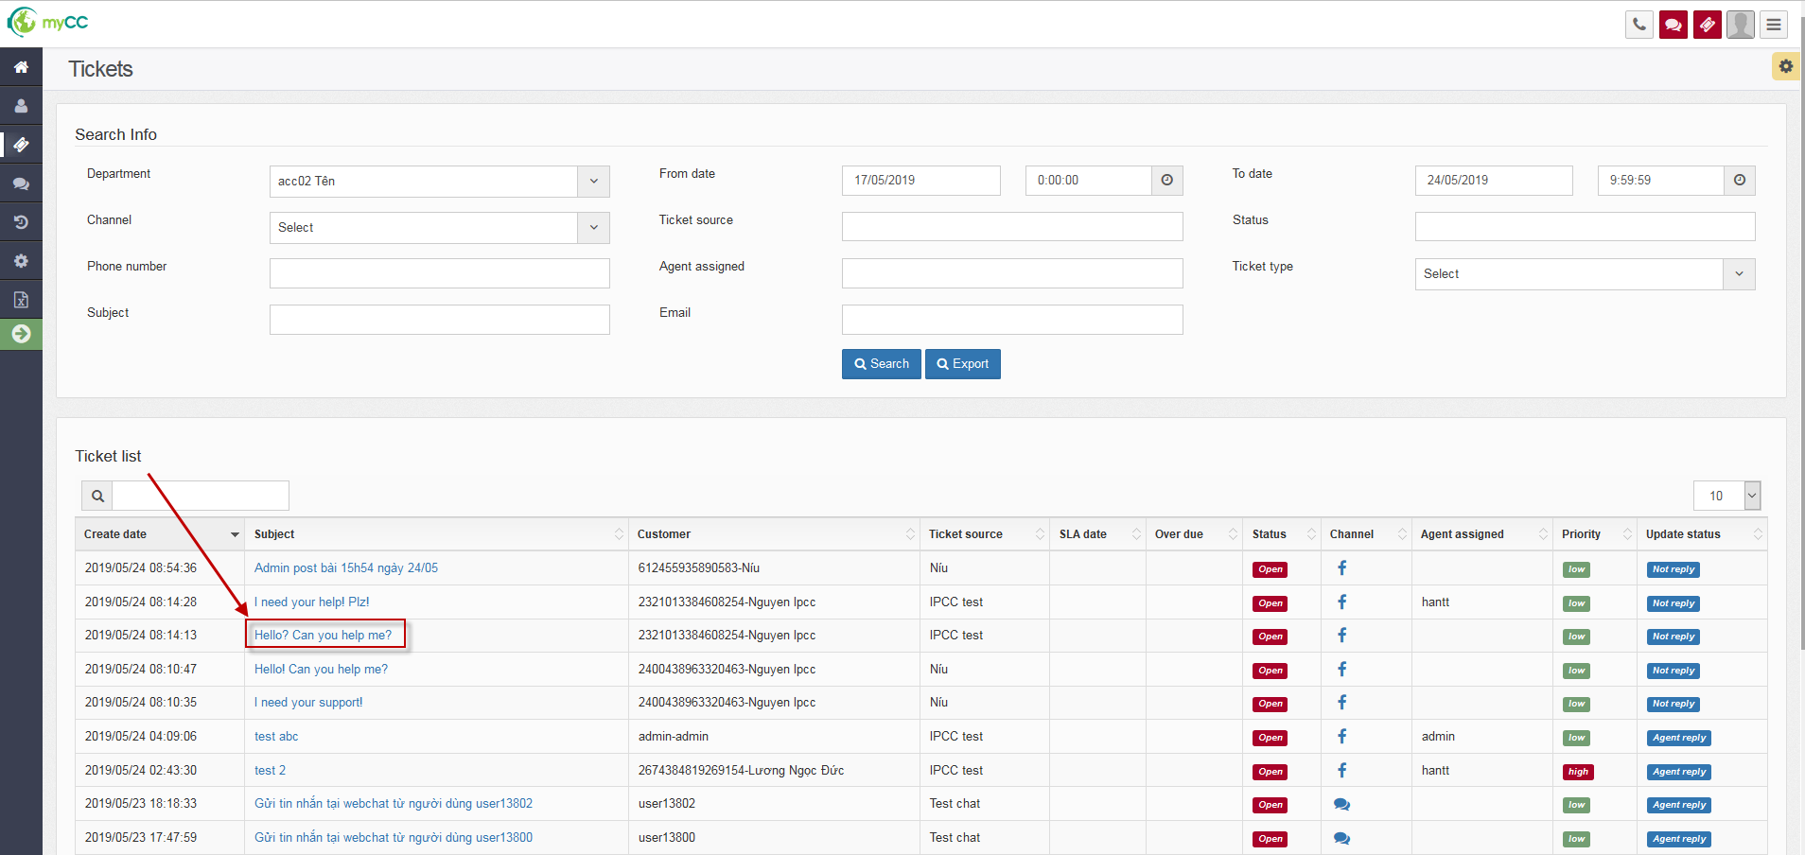

* **The system shows ticket details screen.**

### View Ticket

#### View Voice ticket

* From list of ticket, The user clicks on the Subject of a voice ticket:

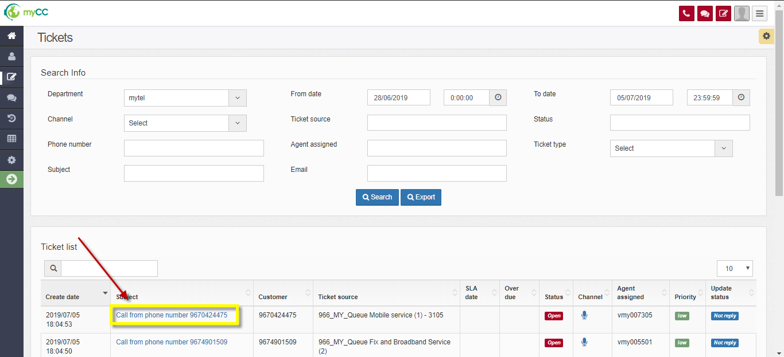

**The system shows Detail of Voice ticket as following:**

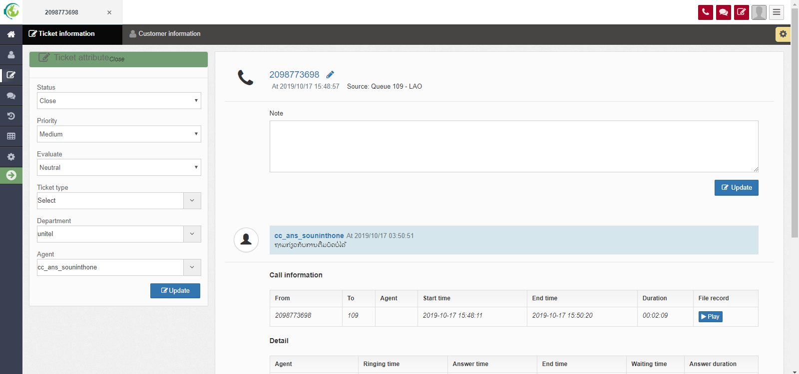

##### Information’s ticket Tab

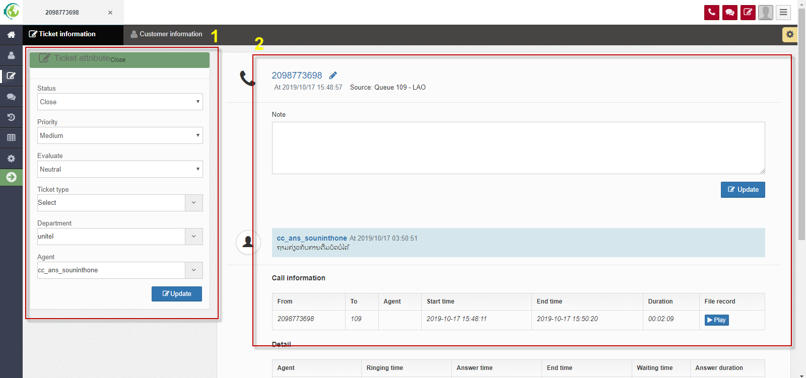

* **Ticket Attribute Frame**: display the same information with different channels (voice, email, facebook)

+ Status: Displays the status of the corresponding Ticket (Open, ReOpen, Closed, Temp Close)

+ Priority: display the priority of the corresponding Ticket (Low, Medium, High)

+ Evaluate: Displays the evaluate of the corresponding Ticket (Select, Positive, Negative, Neutral).

+ Department: show the department of the corresponding ticket (click on the combobox display company of the Agent and the Department of that company)

+ Agent: Displays the Agent assigned by the corresponding Ticket (click on the combobox to display the corresponding Agent of Depatment in combobox)

* + **Ticket Detail frame**: The screen displays different information corresponding to channels: voice, email, and facebook
  + With voice channel:
* General information: Subject, Time, Source
* Note: allows ahe agent to enter customer request
* Call Information: Displays the call flow information from beginning to the end. On this line, users can listen the recording file.
* Detail: Displays flow call information to each Agent

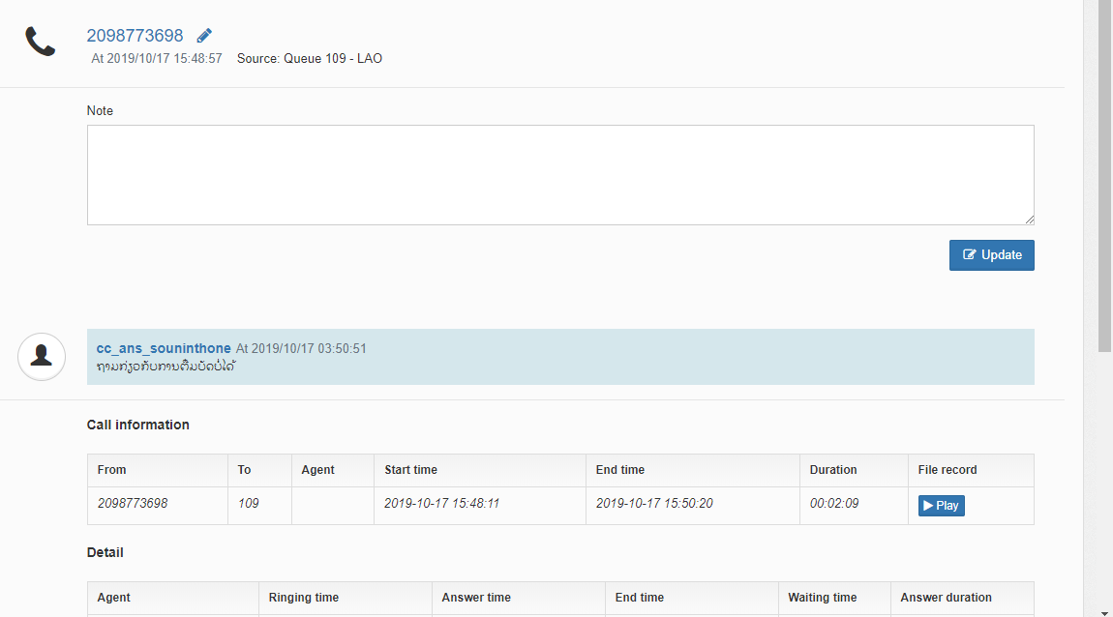

##### Customer information tab

It shows 2 frames:

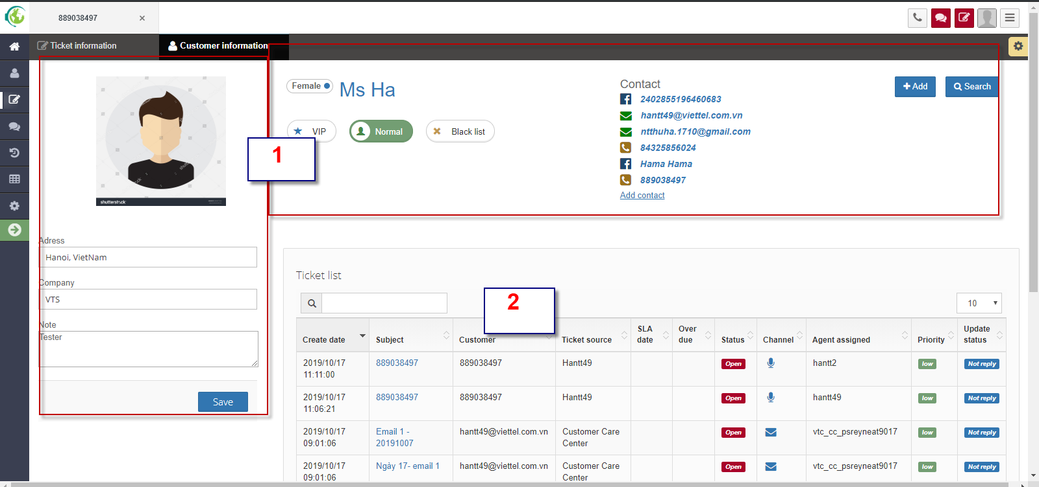

* General information of customers frame: includes:
  + Name
  + Email
  + Phone: you can call to the customer by clicking icon call 
  + Customer Type: Normal, Vip, Blacklist
  + Company
  + Address
  + Note

The user edits information and click “Update” button to save.

* Ticket list frame: display the customer's ticket history interactively to the system

#### Show details of Ticket Email

* On the Grid Ticket list, users click on the Subject of a Ticket with the Channel as Email
* **The system shows the screen as following:**

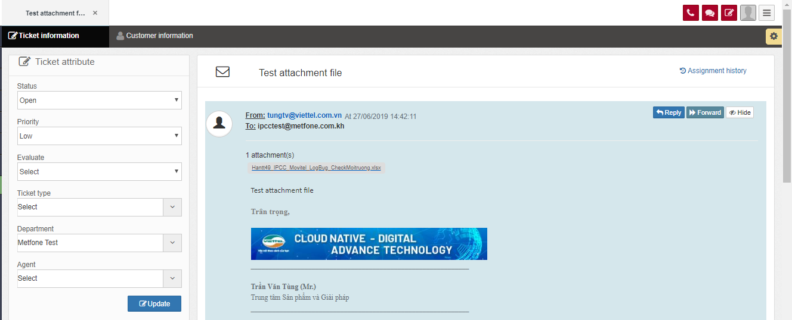

* Ticket information tab:
  + Ticket Attribute frame: displays the same information as the voice ticket
  + Ticket Detail frame: displays the content of the email that the customer sent, allowing the Email Agent to reply, Forward email.

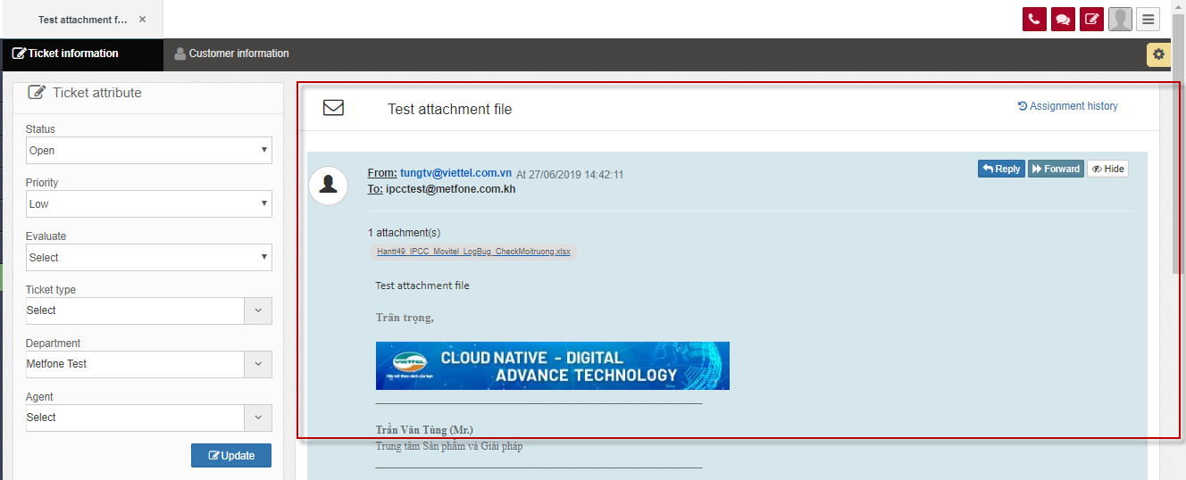

* Customer information tab: the same as Voice channel.

### Update ticket

#### Update at the Ticket attribute frame

* The user modifies the fields that he wants to change on the Ticket attribute frame
* Click "Update" to make changes to the system

#### Save customer requests (with channel voice)

* With channel as voice, user saves customer request at Ticket Detail frame

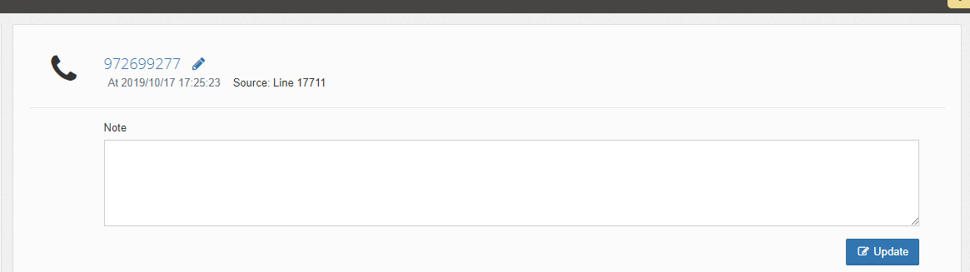

* The agent enters customer request information into the Note box
* Click "Update" to save to the system
* Allows the agent to save many times.

## VOICE FEATURES

### Voice Inbound features.

- The following only describes reception with the case of Agent configuration received on Webphone. In the case of a Softphone configuration agent or normal IP Phone will not be described here (when the device is outside the IPCC system).

#### Display a notification of a call

- Display the notification on the Agent screen when there is an Inbound call distributed.

- When an inbound call is distributed to agent, agent’s screen will show:

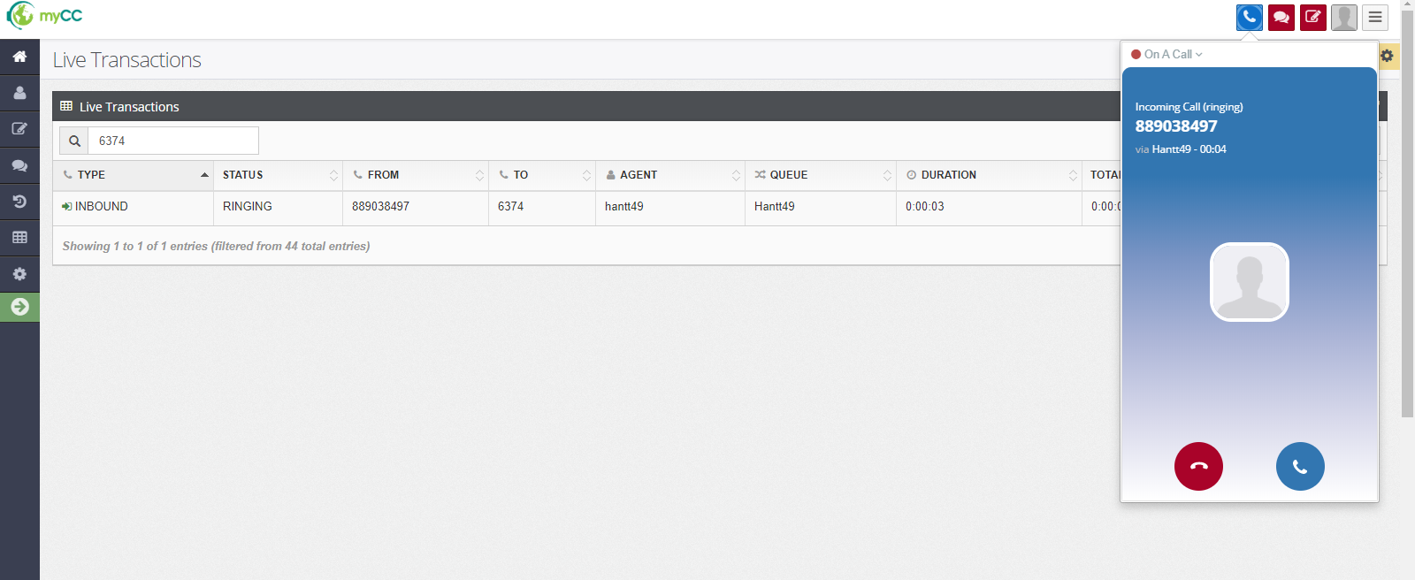

* + Call status: **RINGING**
  + Agent status: **On A Call**
  + Options: Receive (blue button), Reject (Red button).

#### Receive/ Reject a call.

* User can receive or reject a call.
* **Receive a call**

When a call is distributed, user click icon blue on Webphone to receive the call.

* + Call status: **ANSWERING**
  + Agent and customer talk with each other.
  + The system automatically pops up the ticket screen, allowing the agent to record customer requests.

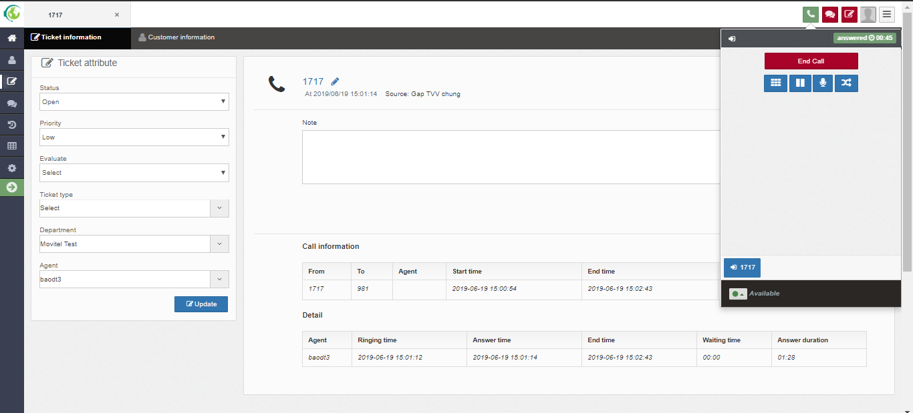

* **Reject a call**

When there is an Inbound call distrubuted to the Agent, the Agent performs one of the following actions, the transaction returns to the queue, continues to find the Agent free:

* + Click button End Call (red button) on Webphone
  + Do not pick up the receiver (after a time-out period, the transaction will return to the queue, continue to search for Agent free).

#### Mute/ Unmute

* This function allows Agent to mute / unmute when talking to the customer.
* **Mute:**
  + Agent clicks The “**Mute**” icon:

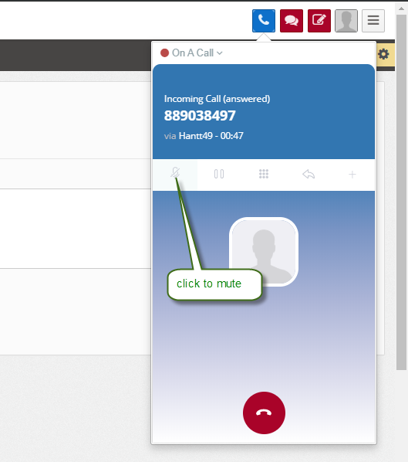

* + After clicking The “Mute” icon:
    - “**Mute**” 🡪 “**Unmute**”

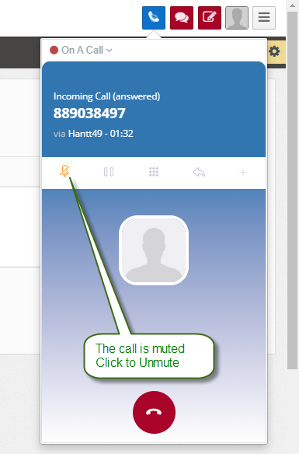

* + - Voice stream: Agent hears the customer speak, and the customer does not hear Agent say.
* **Unmute:** 
  + Agent clicks The “**UnMute**” icon:



* + After clicking The “Unmute” icon:
    - “**UnMute**” 🡪 “**Mute**”
    - Voice stream: Agent and Customer talk to each other normally.

#### Hold/ Unhold

* The function allows Agent to hold the call / unhold the call while talking with Customer.
* **Hold a call:**
  + Agent clicks The “**Hold**” icon:

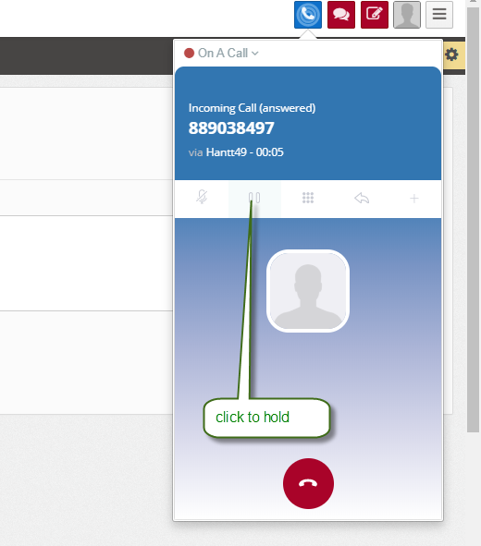

* + After clicking The “Hold” icon:
    - “**Hold**” 🡪 “**Unhold**”

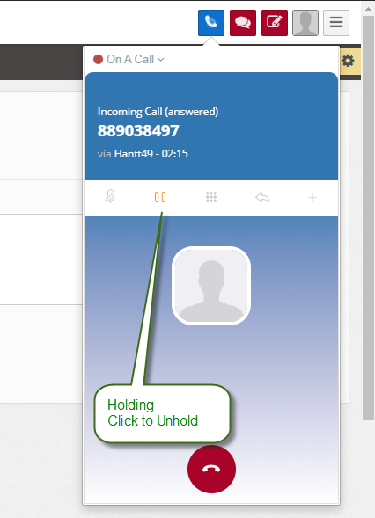

* Voice stream: Customer hears ringback tones, Agent and Customer don't talk to each other anymore
* **Unhold:** 
  + Agent click the “**UnHold**” icon:



* + After clicking “Unhod” icon:
    - “**Unhold**” 🡪 “**Hold**”.
    - Voice stream: Agent and Customer talk to each other normally..

#### Transfer.

- The function allows Agent to transfer Inbound call to another Agent, to expert (Phone number is outside the system), to another call flow (call flow can be: Queue, a branch of music playback, Agent).

- When the call is in ANSWERING state, Agent clicks on the transfer icon on Webphone.

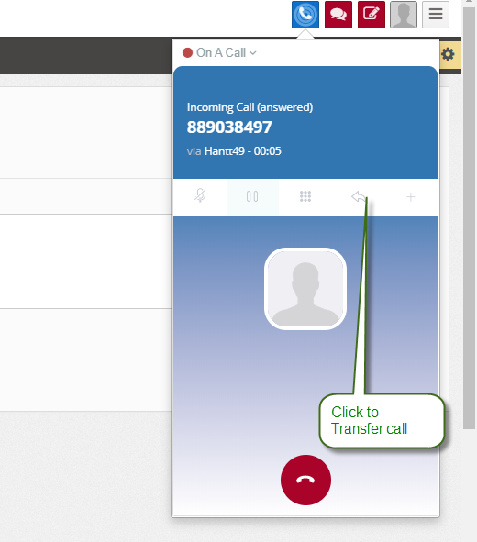

* The system displays a combobox to allow the selection of where to call:

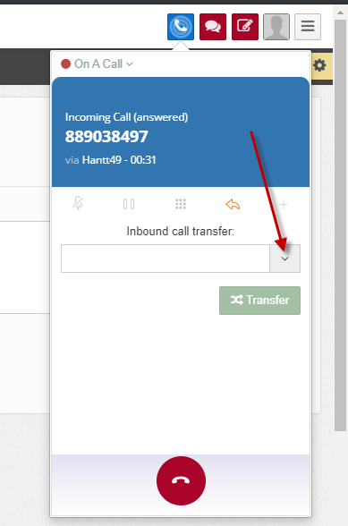

* Agent click to combobox 🡺 the options are listed to chose: **call flow, Queue Agent, Expert.**

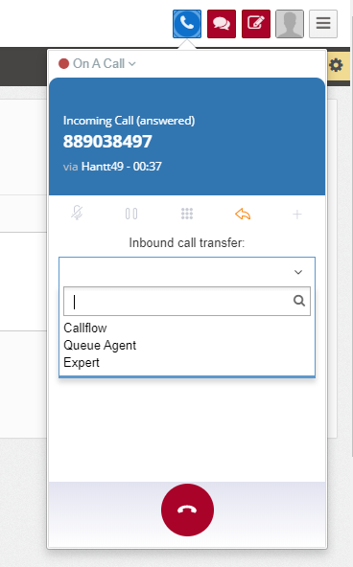

##### Transfer calls to Agent of any Queue

- The function allows Agent to transfer Inbound call to Agent of any Queue to support answer and advice for Customer.

- Step 1: Agent (temporarily called Agent A) click on the icon when answering an Inbound call – Choose: Transfer the call to "Queue Agent"

🡪 The system displays additional combobox to select Queue:

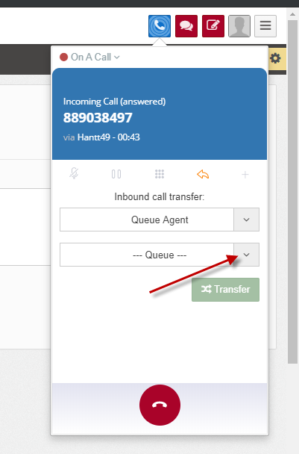

* Step 2: Agent A chooses one queue from list:
* The system displays the combobox to select agent:
* Bước 3: Agent A chooses Agent B.

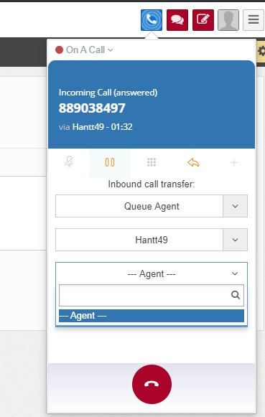

* Bước 4: Agent A presses “**Transfer**” button:
  + Agent A is disconnected from the call
  + The call is distributed to Agent B. Agent B picks up to continue customer support.

##### Transfer inbound call to the professor.

* The function allows Agent to transfer calls to experts.
* Step 1: Agent A click “Transfer” icon  when answering inbound call

Agent A chooses value: Transfer to The professor:

* The system shows the list professor:

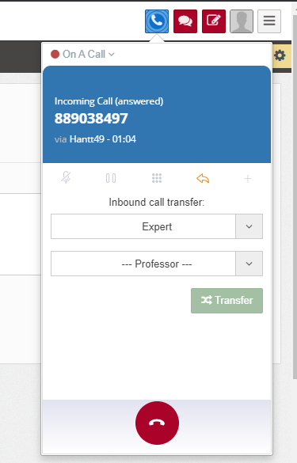

* Step 2: Agent A chooses one from list professor.
* Step 3: Agent A clicks “**Transfer**” button:
  + Agent A is disconnected from the call
  + The call is ringing to Expert. Expert picks up to continue customer support.

*Note: The number of professor had been declared at menu Settings/CallSettings/ Professors:*

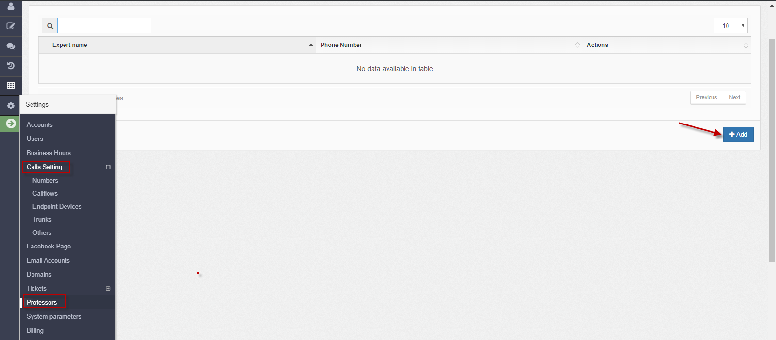

##### Transfer inbound call to Call flow.

* The function allows Agent to divert calls to another Callflow (Callflow can configure the Agent extension, to Queue, to the music branch, ...).
* Step 1: Agent A clicks “Transfer” icon  when answering inbound call. Agent chooses value: Transfer to **“Callflow”**
* The system shows combobox to select business’s callflow:

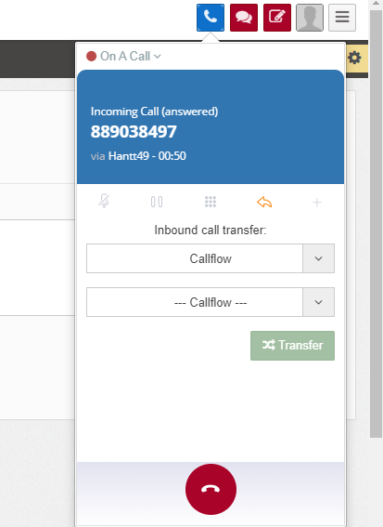

* Step 2: Agent A chooses one callflow (which is configured by administrator, it may be a queue, a branch to play waiting music, callflow)

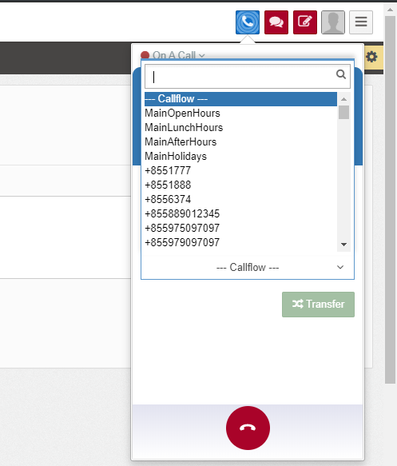

* Step 3: Agent A click “**Transfer**” button.
  + Agent A is disconnected from the call.
  + The call is transferred to the corresponding callflow.

#### End call

* Agent or Customer can end call while talking.
  + Customer proactively terminates the call
  + o Agent interrupts the call on the Webphone by pressing the End call button.

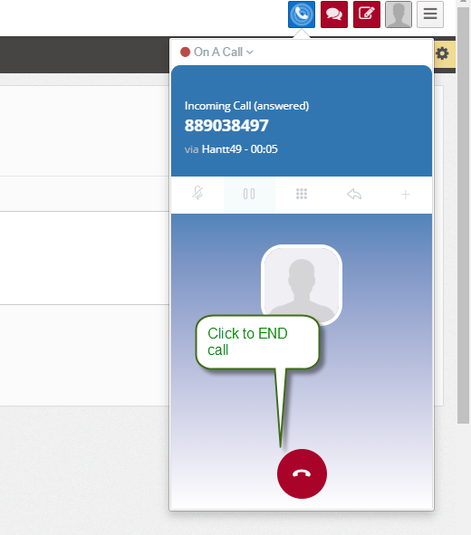

* When the call ended:
  + Agent's status changes to After call work.
  + After a period of time (the parameter has been configured by the administrator), the Agent's status will be automatically transferred to Available to receive the next call.

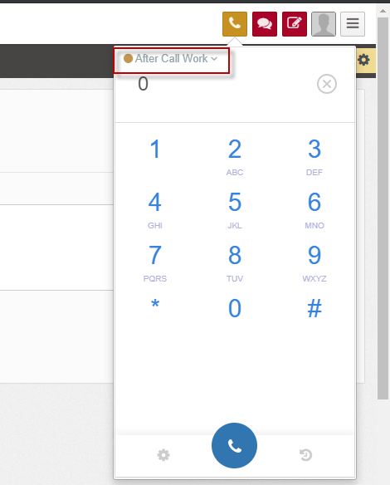

### Voice Outbound features

#### Call out proactively

* Agent proactively calls out to any phone number (including fixed and mobile numbers) from the WebAgent.
* Step 1: Agent click call icon on the screen:

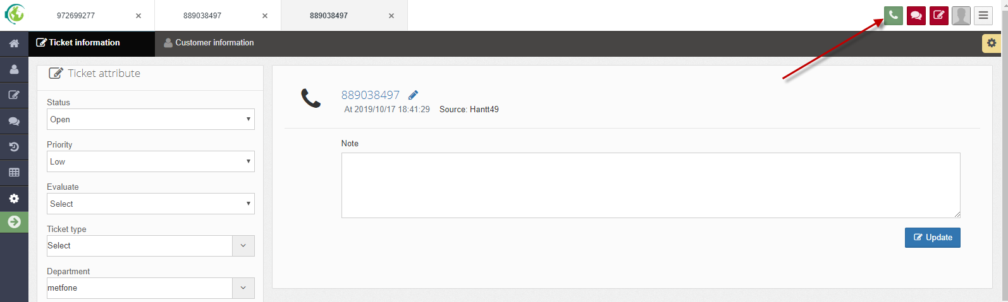

* The system pops up webphone screen:
* Step 2: Agent enters phone number and click to Call:

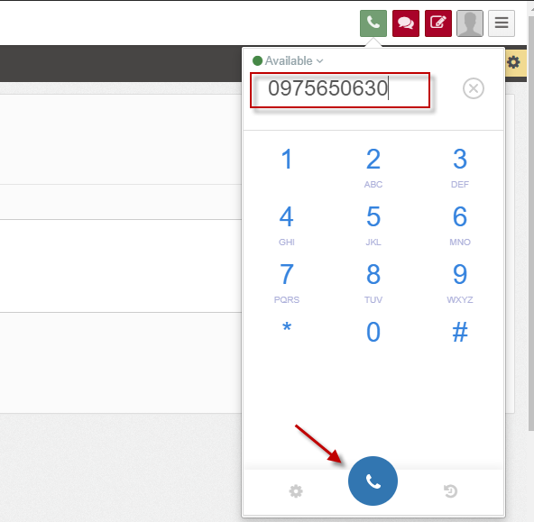

* When the system is dialing out: call status displays "Dialing".

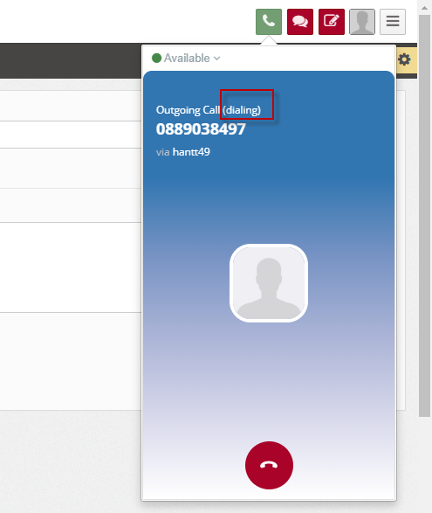

* When the call is ringing to the customer: the call status displays "Ringing"

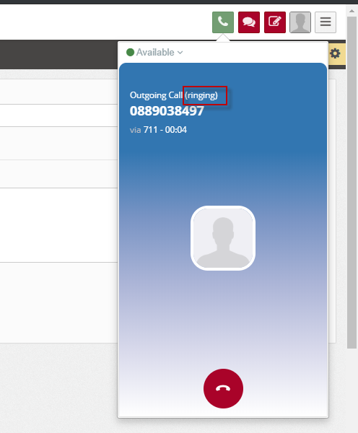

* When Customer picks up: Call status displays "Answered":

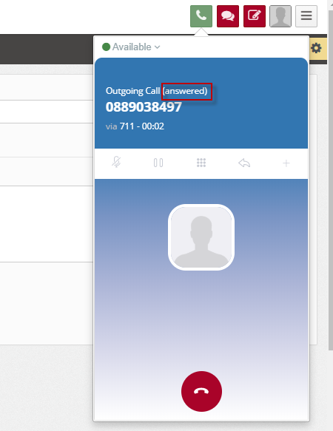

* Notes:
  + With the outgoing call: the system does not pop up the Ticket tab to save customer request information
  + When the Agent and Customer are connected on outgoing call: Agent can also perform the interrupt, Hold, Mute, and Transfer actions similar to the incoming call.

## CHAT FEATURES

### Customers send chat requests

- Customers can send chat requests to the system from webchat.

- The chat screen of the client on the web chat is displayed as follows:



* Customer click “**Chat with us**” button to send requested chat.
* The screen displays:

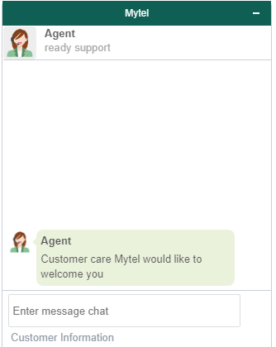

* Customer fill text in “*Enter message chat*” 🡪 press Enter to send.

### New chat notification

* The function allows displaying notifications to an agent when a chat is distributed.
* When a customer send chat to the system, the system will search for an agent who has an available chat channel to distribute.
* Agent's screen will display the following message:

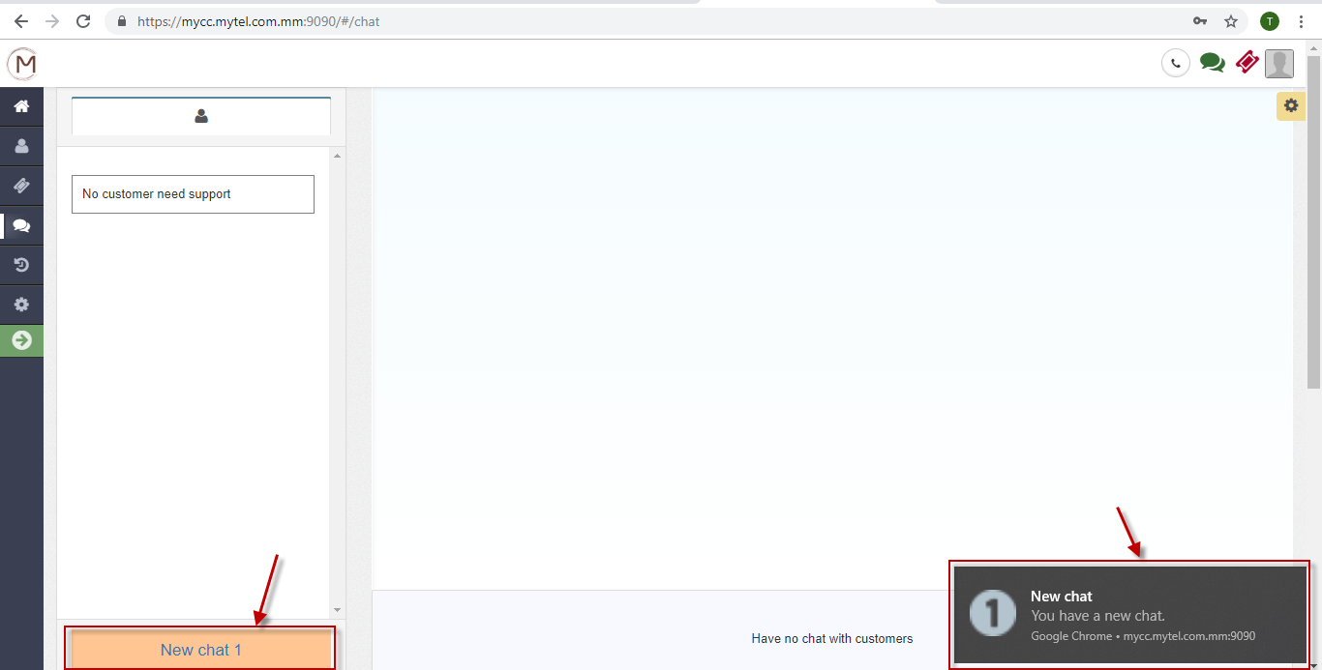

* + New chat (at left corner) notification: displays the number of chat being distributed to the agent that the Agent has not yet received. Each agent can receive one or more chat simultaneously (depending on configuration).
  + Notification (at right corner): If the agent is not focusing on the chat tab, the system still displays the notification so the agent could know.
  + An agent is ready to receive a new chat when:

o Logged into WebAgent module, the Chat channel status is Available.

o Total number of chats being received < Maximum chat number allowed.

### Receive/Reject a new chat

* The function allows users to receive or reject a new chat.
* **Receive a new chat**: When a chat is ringing to an agent, click button  to receive 🡺 The system pops up a screen:

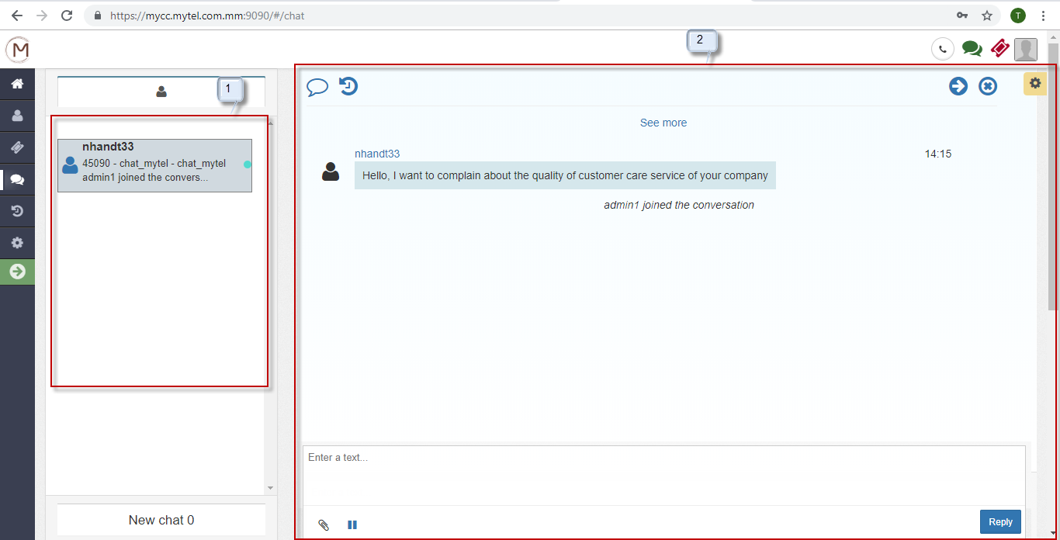

* + 1: The frame displays a list of chat transactions to Agent
  + 2: The framework allows chat between the agent and a customer.
* The customer screen displays as follows:

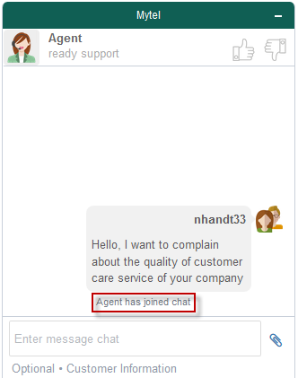

* **Reject a chat**: When there is a chat distributed to an agent --> The agent do not click the "New chat" button, after a timeout the chat transaction will return to Queue, continue to search for another available agent.

### An agent does chat with a customer.

* The function allows an agent chat with a customer after receiving a new chat.

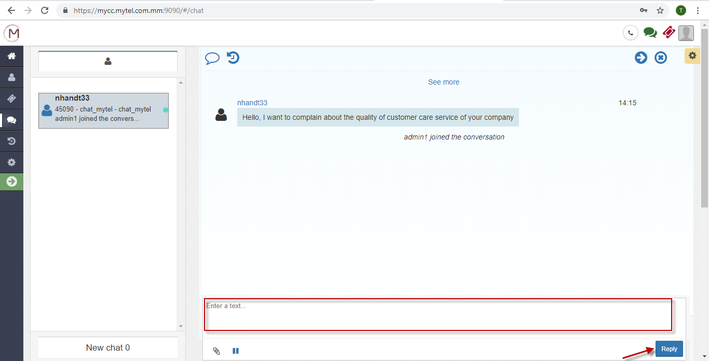

* The agent fill text to “*Enter a text*” frame
* The agent click “**Reply**” button or press Enter to send chat.
  + The agent’s chat screen displays:

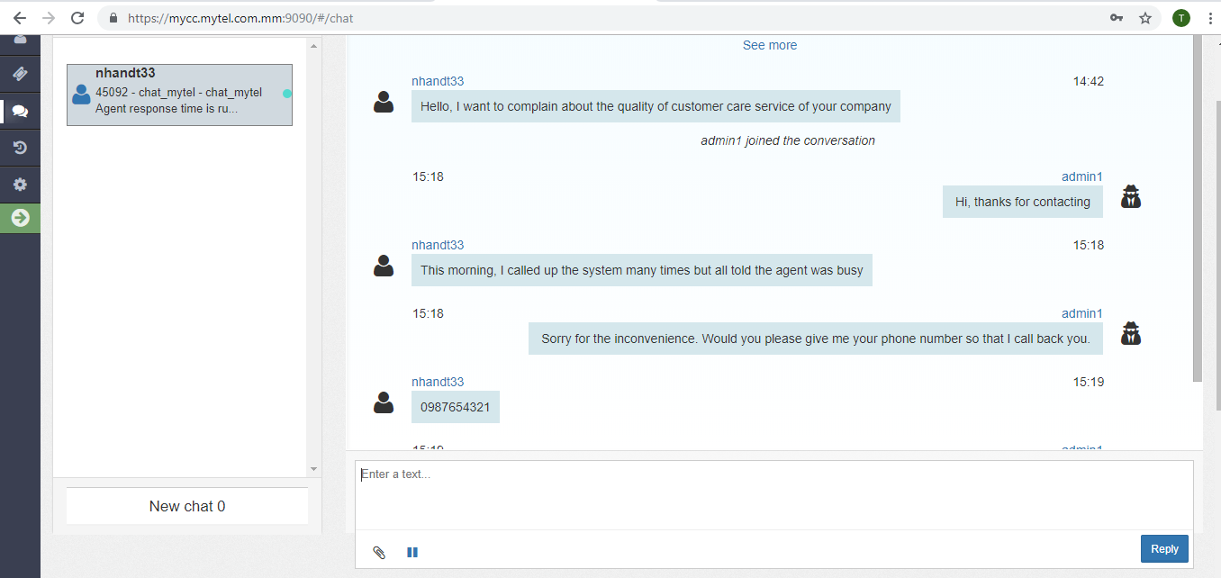

* + - The agent could send files to the customer by clicking  icon.
    - Click “**See more**” icon to see the conversation history.
  + The customer’s screen chat displays:

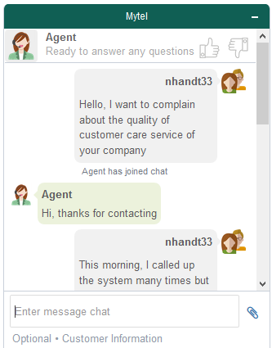

* + - The customer could send files to the agent by clicking  icon.
    - Customers can evaluate agent's service quality well or poorly by clicking  icon or  icon.

### Agent hold chat

* When the agent needs to search or talk to others, the agent can hold chat by clicking hold icon.
* The agent’s screen shows:

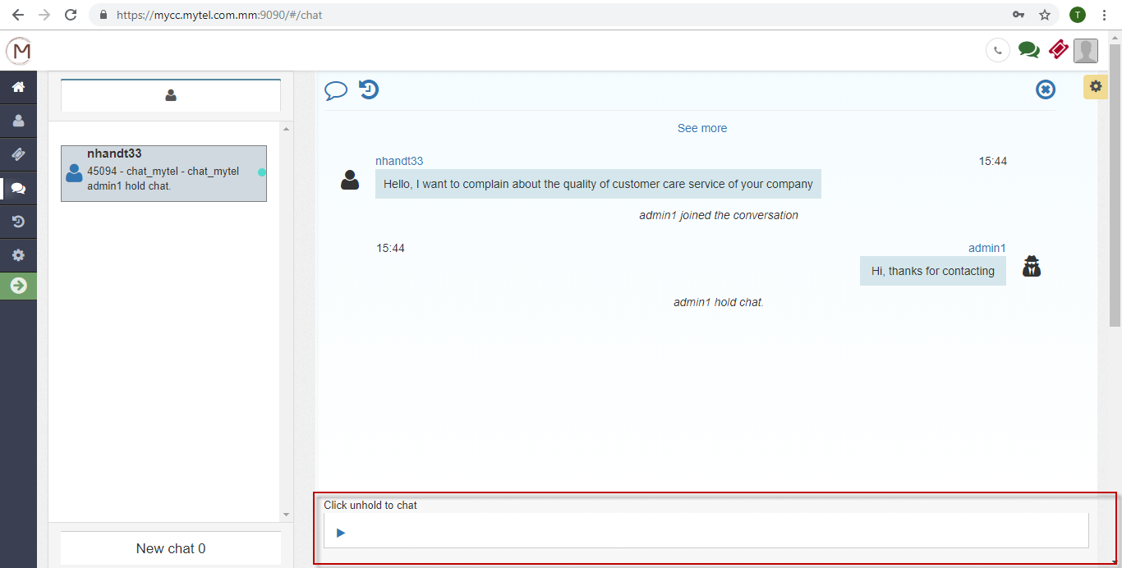

* + The agent could not send chat to the customer.
  + The customer still sends chat to the agent normally.
* To unhold, the agent click unhold  icon 🡺 The agent and the customer chat normally.

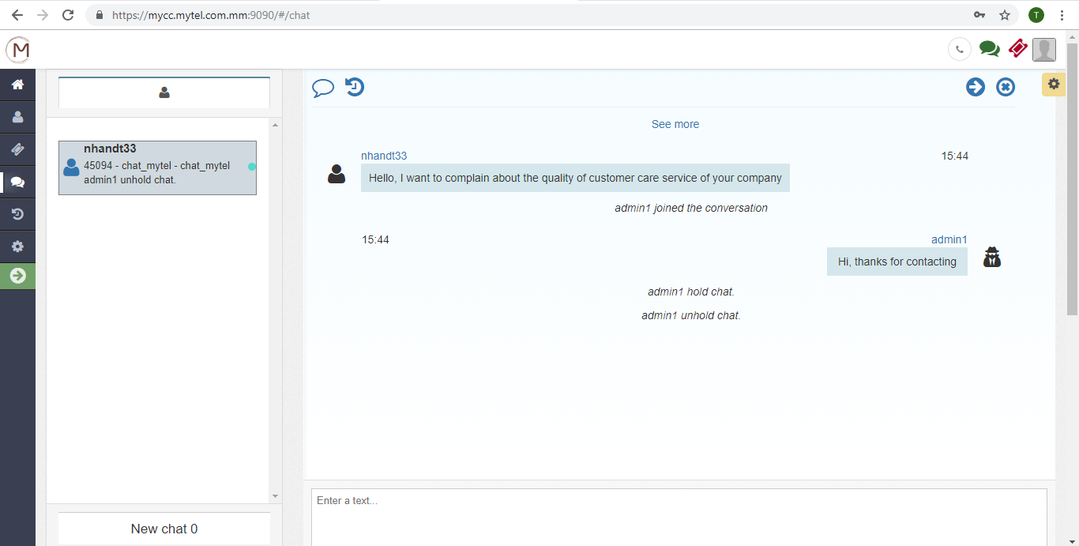

### End a chat

A chat is ended when:

* The agent ends the chat:
  + The agent click icon x 🡺 A confirm is displayed:

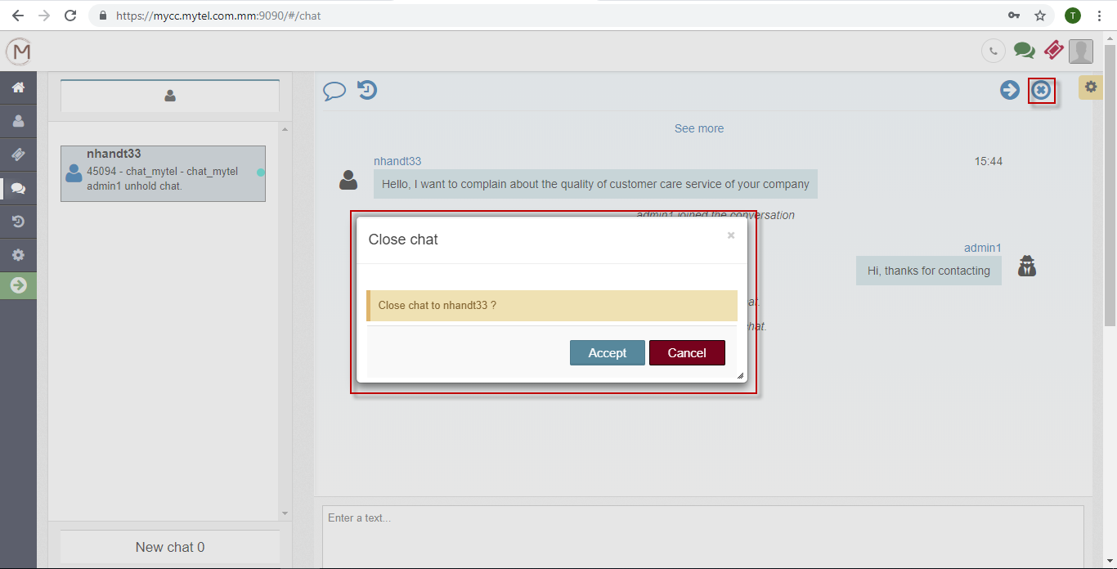

* + Click “**Accept**” button to end or click “**Cancel**” to cancel.
* The customer ends the chat:
  + The customer clicks “Option” menu, chooses “**End chat**”.

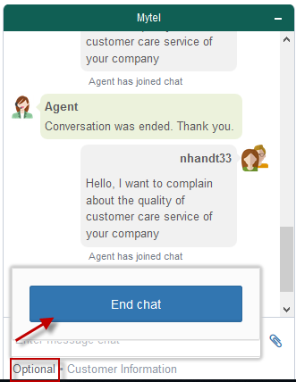

* A confirm is displayed:

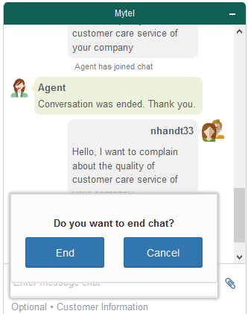

* + The customer clicks “**End**” button to end chat or “Cancel” button to cancel.

## EMAIL FEATURES

### View content of customer's email

* The function allows an agent to view the content of an email sent by the customer when processing an email's ticket.
* From the list of tickets, the agent clicks to view detail email. The system shows “Detail ticket email” which shows the content of email:

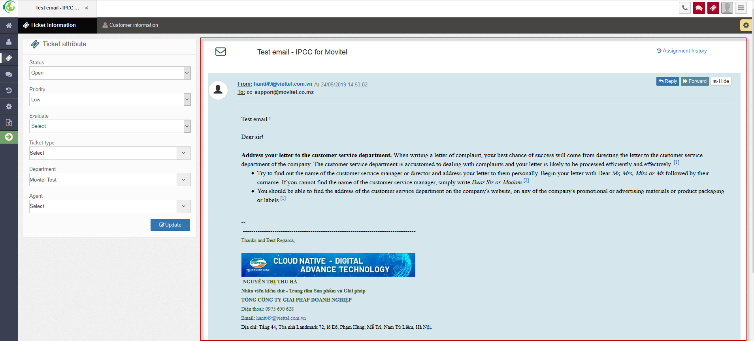

### Reply email

* The function allows an agent to reply customer’s email.
* From “Detail ticket email”, the agent clicks “Reply” button 🡪 The system shows a screen to compose:

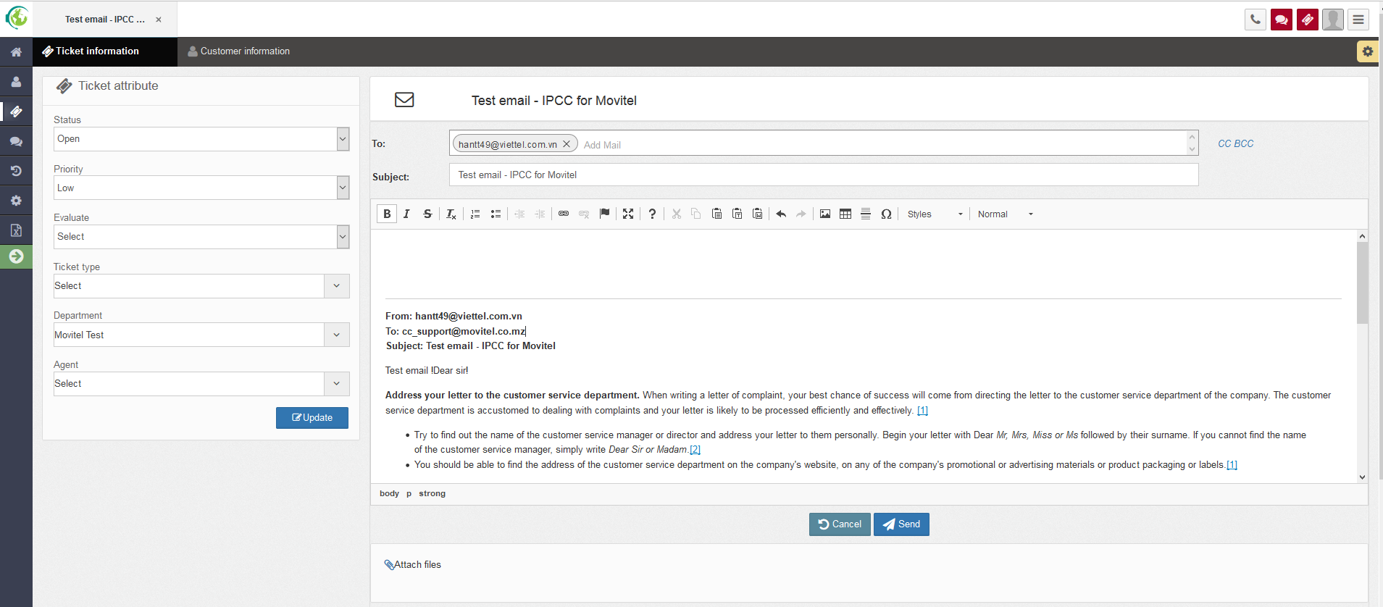

* The agent inputs data:

To: this is required information. The system allows to enter multiple email addresses, press enter to confirm the email.

CC: this is not required information.The system allows to enter multiple email addresses, press enter to confirm the email.

BCC: this is not required information.The system allows to enter multiple email addresses, press enter to confirm the email.

Subject: this is required information, allow users to enter string data.

Content: this is not required, users can customize the format in email content using the support editor features.

Attach file: this is not required. Allows users to select multiple files at once so that the total file size does not exceed 10MB.

Notes: It is not allowed to leave both email and attachments blank, one of the two required information is required.

Users click “Send” button to send email to customers.

### Forward email

* The function allows an agent to forward the customer’s email to single or multiple addresses email.
* From “Detail ticket email”, the agent clicks “Forward” button 🡪 the system shows a screen as follow:

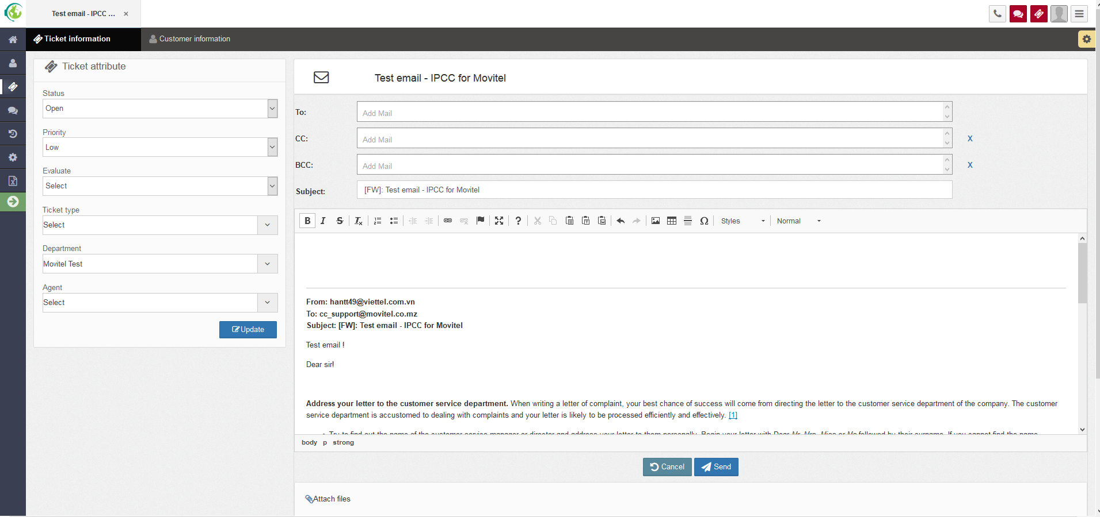

* The agent edits the email's content either or not.
* Click “**Send**” button to forward email.

## FACEBOOK FEATURES

### View customer’s posts/comments

* The function allows users to view the content of post / comment of customers on fanpage when the post / comment ticket is assigned to them.
* From the ticket list screen, users click on the detail view of 1 Ticket Facebook 🡪 Ticket Detail Facebook is displayed, in which the post / comment content of the customer is as follows:

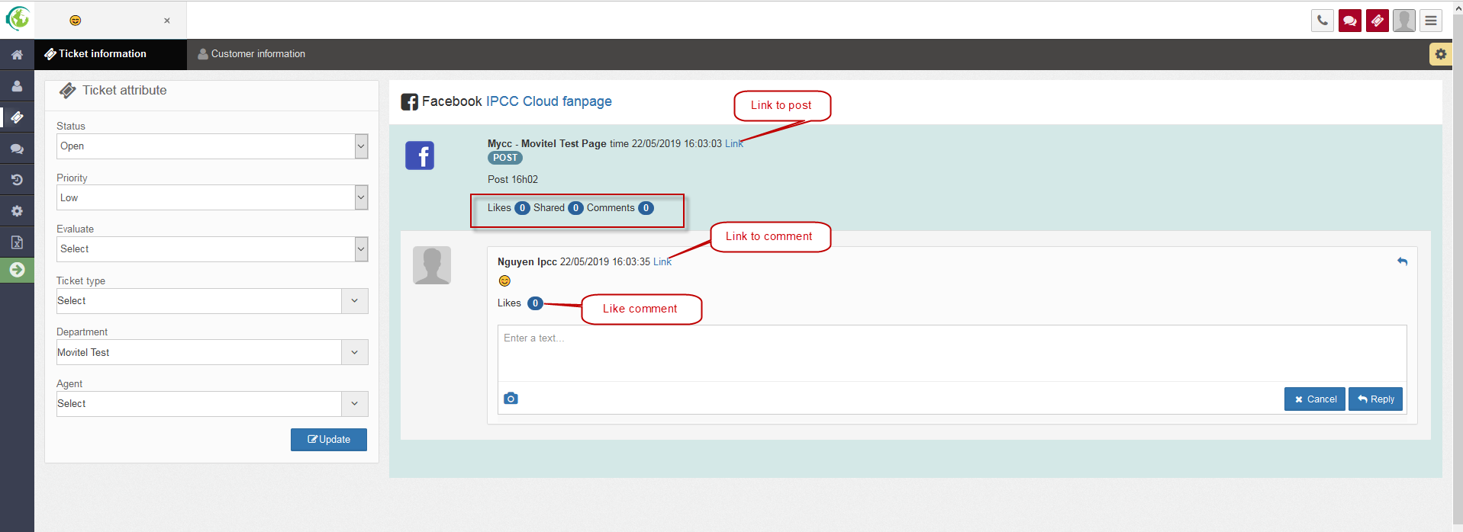

### Respond to tickets from Facebook posts/comments

* The function allows users to respond to the ticket Facebook Post / Comment of the customer.

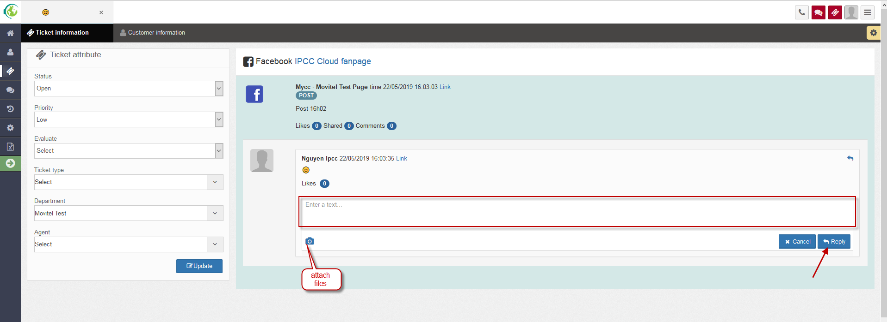

Users input data for:

Content: this is required information.

Choose attach files: this is not required, allows format type: .jpeg, .png, .jpg and lower than 5MB.

## MONITORING FEATURES

### Dashboard

* The function allows users to monitor some general monitoring information of the whole enterprise in real time. Statistics for the current day.
* Agent click on menu *Monitor – Choose “Dashboard”*

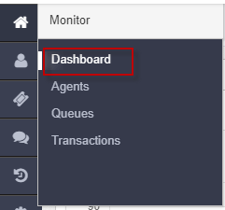

* The Dashboard screen is shown:

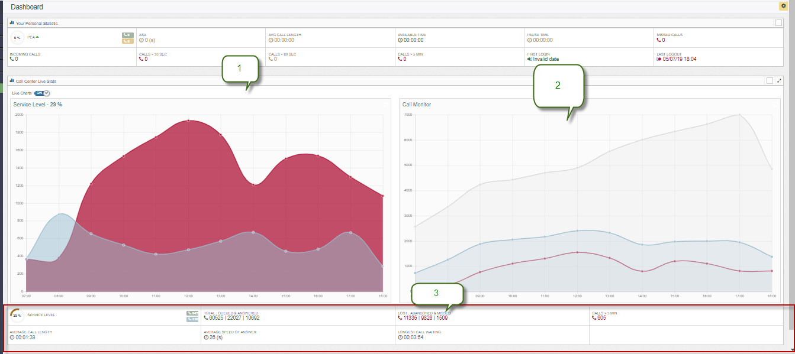

* Includes:
  + (1): The chart shows the percentage of service levels through the time zones:
  + Blue line: the number of receiving calls within 20 seconds
  + Red line: Other

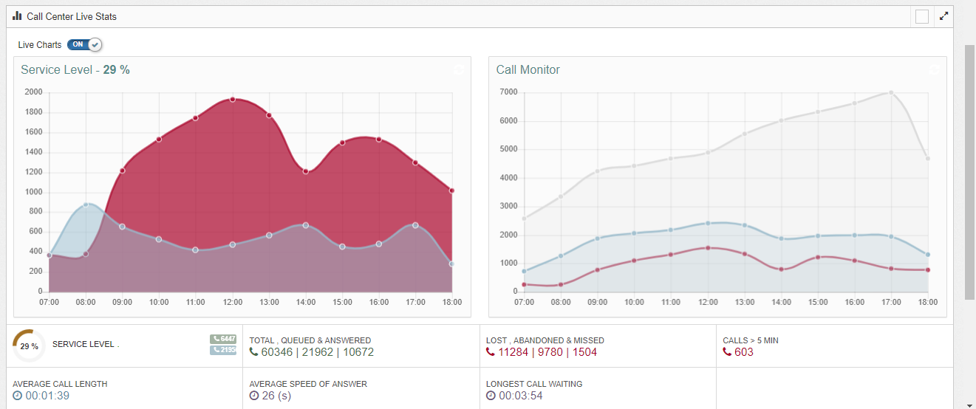

* + (2): Call monitoring chart for each time zone:
  + Gray line: the number of calls to the system
  + Blue line: the number of calls to Queue
  + Red line: the number of missed calls.

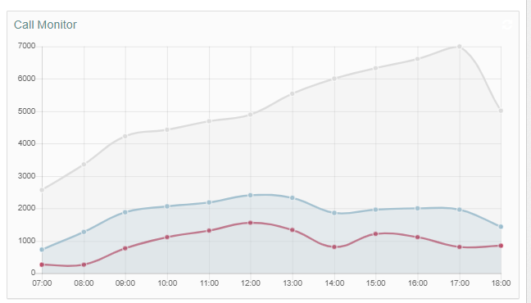

* + (3): The frame shows the general indicators of the day:
    - Service level (unit: %): formula:
  + **SERVICE LEVEL = (**The number of receiving calls within 20 seconds

**/ (ANSWERED + LOST) ) * 100**

* + - TOTAL, QUEUE & ANSWER: total calls to system, calls to queue, answered calls.
    - LOST, ABANDONED & MISSED: The number of unanswered calls, The number of unanswered calls due to the customer interrupts the call, The number of unanswered calls due to the agent did not pick up or rejected the call.
    - CALL > 5 MIN: The number of calls has answered time > 5 minutes
    - AVG CALL LENGTH: Average answered time.
    - AVERAGE SPEED OF ANSWER: The average waiting time of the customer before being answered, from the time of entering the queue until it is answered, only for answered calls..
    - LONGEST CALL WAITING: The longest call waiting.
  + Quantity : Total calls to the system, Calls to Queue, Answered calls, calls which duration is greater than 5 minutes.
  + Time: Average call time, Average answering speed, Longest call waiting time.

### Queue monitor (Live queues)

* The function allows supervisors to monitor monitoring information of enterprises' Queues in real time. Statistics are calculated in the current day.
* On Monitor menu, agent chooses  *“Live queues”*

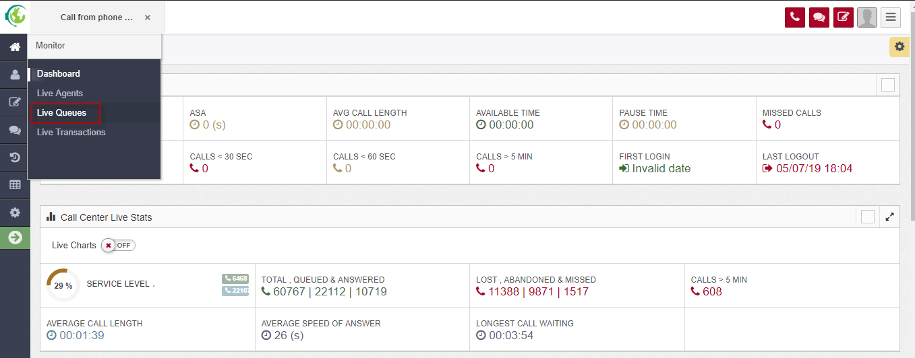

* The screen is shown:

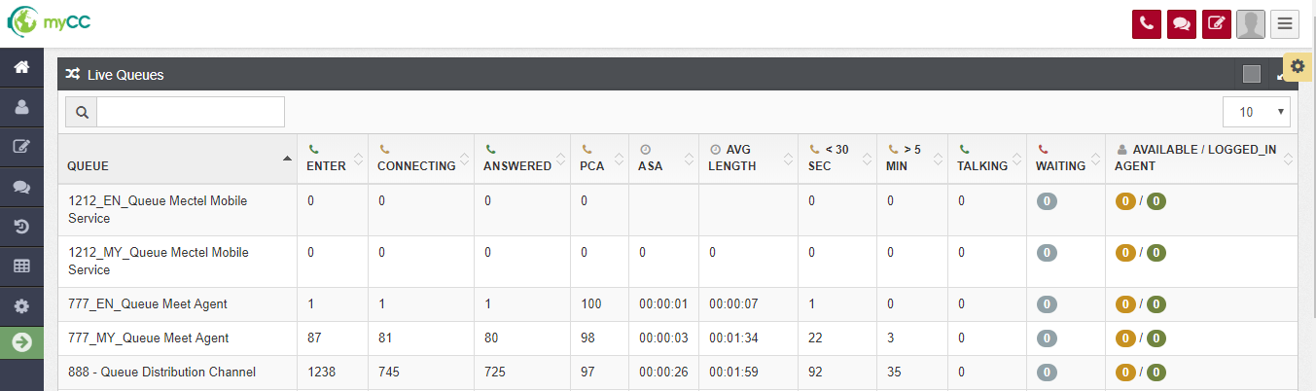

* Includes:
  + QUEUE: The list shows all queues of the enterprise, each Queue is displayed on one line.
  + ENTER: the number calls to Queue
  + CONNECTING: total times of ringing
  + ANSWERED: the number of answered calls.
  + PCA : Percentage of calls answered
  + ASA: Average speed of answer: The average waiting time of the customer before being answered, from the time of entering the queue until it is answered, only for answered calls.
  + AVG CALL LENGTH: the average responsed time
  + > 5 MIN: the number of calls which its duration is greater than 5 minutes.
  + < 30 SEC: the number of calls which its duration is less than 30 seconds.
  + TALKING : the number of answering calls.
  + WAITING CALLS: the number or waiting calls.
  + AVAILABLE / LOG_IN AGENT
    - AVAILABLE: Agents (were assigned to Queue) are in the Available state on the interface and are not receiving any calls.
    - LOG_IN AGENT: the number of agents (were assigned to queue) already log in.

### Agent monitor (Live agents)

* The function allows users to monitor some monitoring information of agents in real time. Statistics are calculated in the current day.
* On Monitor menu, choose *“Live agents”*

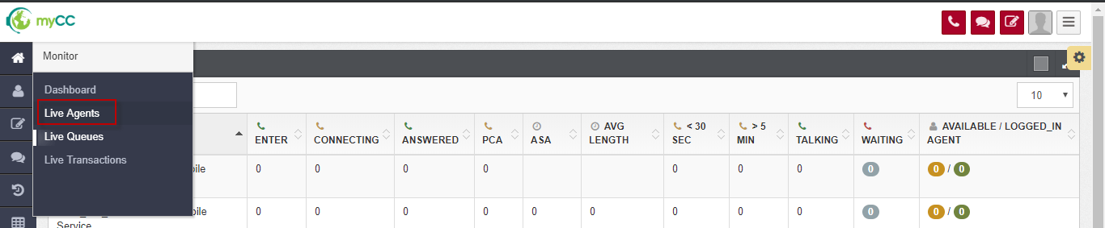

* The screen is shown:

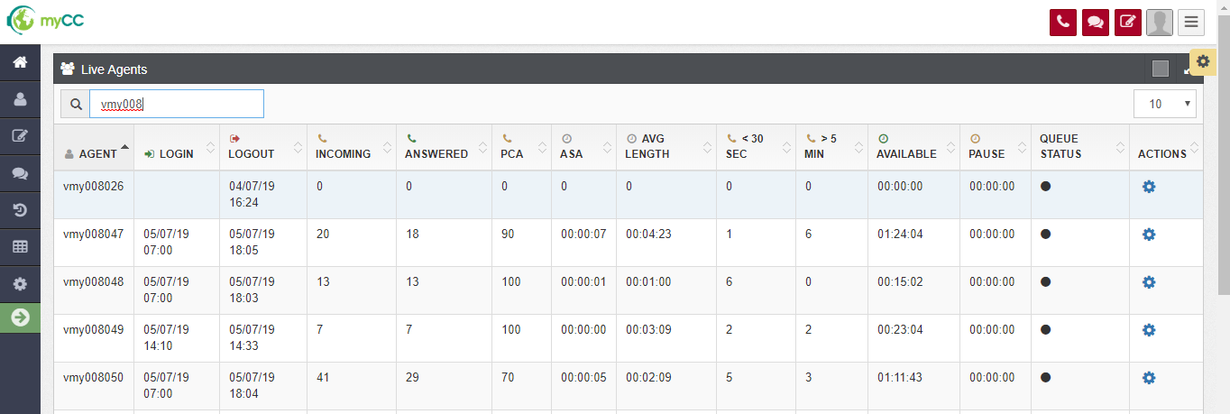

* Includes:
  + AGENT: username’s agent, each agent is in one line.
  + LOGIN : the first time the agent changes voice status to AVAILABLE
  + LOGOUT : the lastest time: the agent changes status to OFFLINE or the agent does logout.
  + INCOMING : the number of ringing times to the agent
  + ANSWERED: the number of answerd calls.
  + PCA: percentage of calls answered
  + ASA: The average waiting time of the customer before being answered, from the time of entering the queue until it is answered, only for answered calls.
  + AVG CALL LENGTH: the average responsed time
  + > 5 MIN: the number of calls which its duration is greater than 5 minutes
  + < 30 SEC: the number of calls which its duration is less than 30 seconds.
  + AVAILABLE: total time: the agent has voice status is AVAILABLE (include time: the agent is answering)
  + PAUSE: total time: the agent has voice status is PAUSED
  + QUEUE STATUS: status when the agent loged in queue.
    - Connected: the agent is answering
    - Connecting: the call is ringing to the agent
    - Ready: the agent’s status is AVAILABLE
    - Wrapup: the agent has just ended one inbound call, is entering customer’s request.
    - Logged_out: the agent has status is OFFLINE or the agent already loged out.
    - Paused: the agent has status is Paused.
    - Outbound: the agent is making an outbound call.
  + ACTIONS: allow the supervisor actively change voice status of the agent.

When click setting icon, it shows:

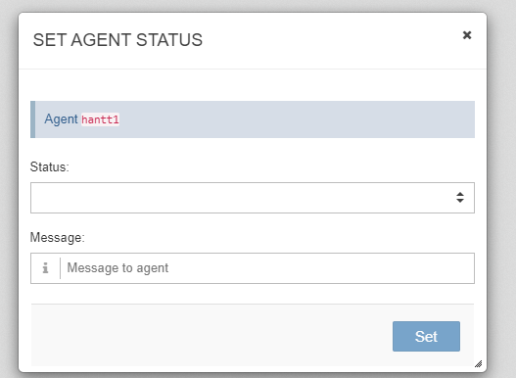

The supervisor choose one value from Status box, enter message, then click Set button.

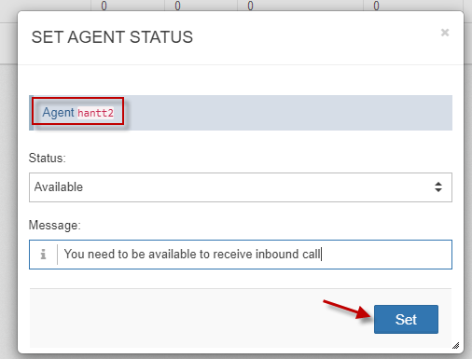

The system do change voice status of the agent and displayes a notification on the agent’s screen:

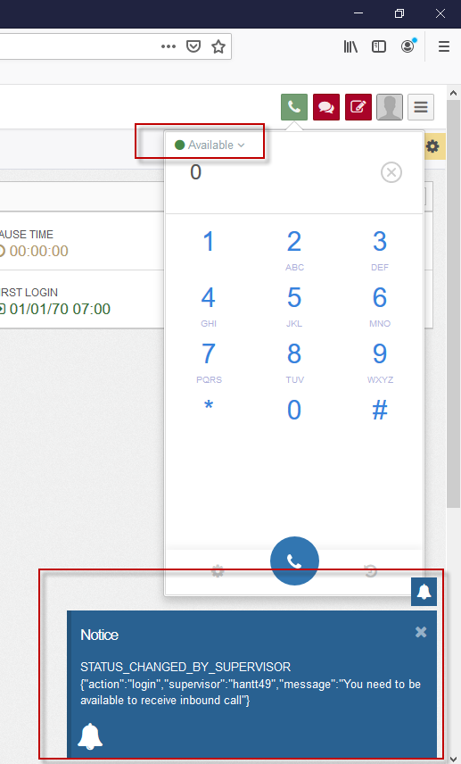

### Transaction monitor

#### Monitoring voice transactions

* The function allows users to monitor ongoing calls in the system, includes: Inbound and Outbound calls, from when the customer starts calling to the system until the call ends.
* On Monitor menu, choose *“Transactions”:*

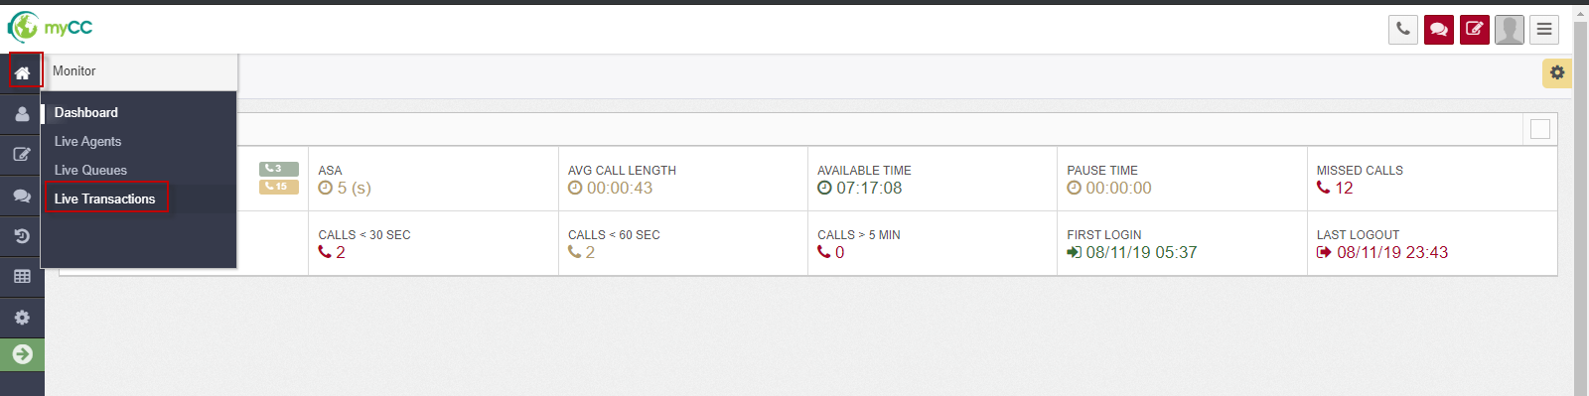

* The transaction monitor screen is shown:

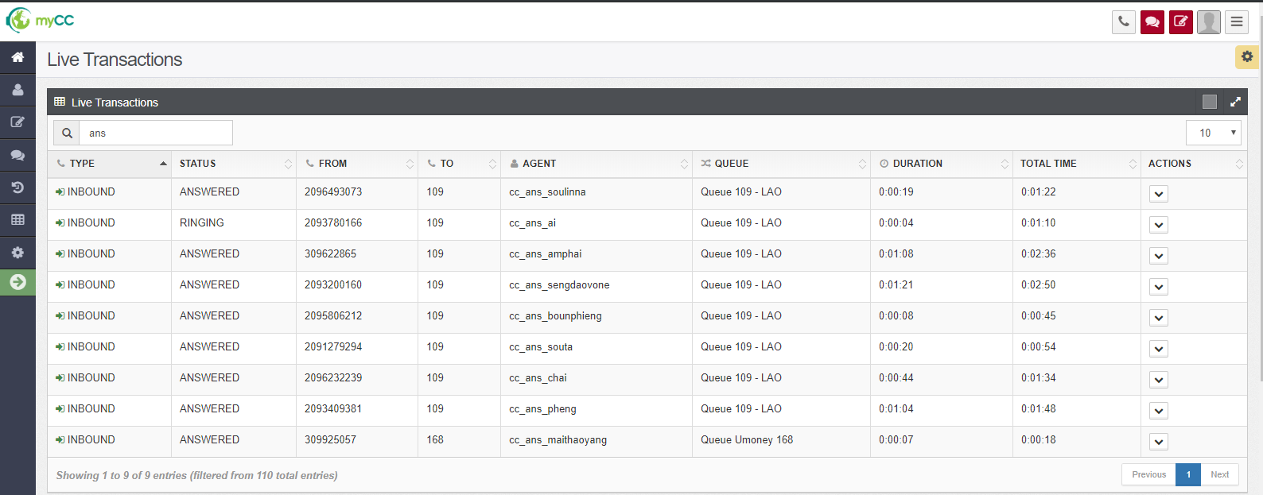

* Includes:
  + TYPE:
    - INBOUND
    - OUTBOUND
    - INTERNAL (internal calls: spy calls, group conversations, reminder …)
  + STATUS: includes:
    - INNITIATED: the call is at IVR
    - QUEUED: the call is at ACD, the system is finding free agent.
    - RINGING: the call is ringing to the agent
    - ANSWERED: the agent answered the call.
  + FROM: the customer’s number (INBOUND) or the number extension of the agent (OUTBOUND)
  + TO: hotline (INBOUND) or the customer’s number (OUTBOUND)
  + AGENT: agent’s username.
  + CONTACT: customer phone number
  + QUEUE: queue is called
  + DURATION: time in state
  + TOTAL TIME: total time of call, from start time to now.
  + ACTION:
    - With ANSWERING call, the list action includes: Listen, Whisper, Conference, Intercept, End call

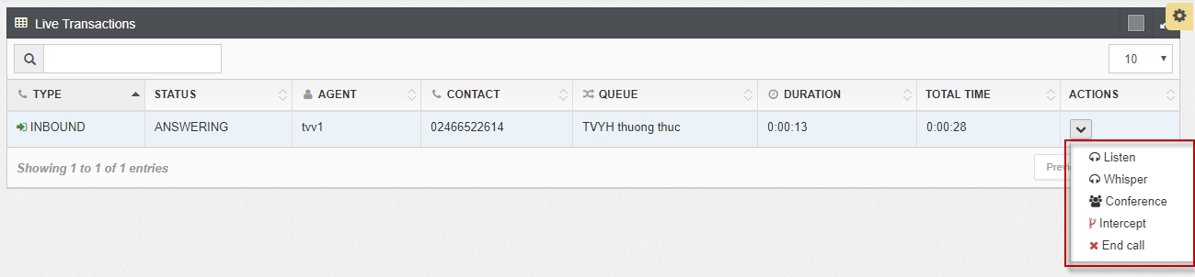

### Transaction support features

#### Group conversation

* The function allows supervisors to participate in the call (Inbound, Outbound) of an agent and a customer.
* At that time, the three sides (Supervisor, Agent, Customer) talk to each other.
* - On the "Transaction Monitoring" screen - users click on the Action Column - select the "Conference" menu.

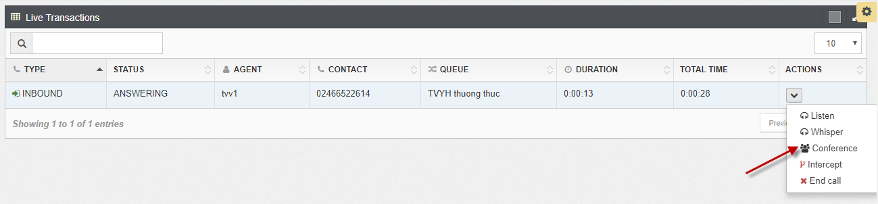

* The call is ringing to Supervisor’s webphone.
* The supervisor picks up phone 🡪 Three sides talk to each other.

#### Listen (Eavesdrop)

* The Function allows a supervisor to eavesdrop on Inbound and Outbound calls that take place between an agent and a customer. When the supervisor eavesdrop, the agent and the customer cannot hear the supervisor said.
* On *“Transaction monitor” screen* – Click Action column – choose **“Listen”**

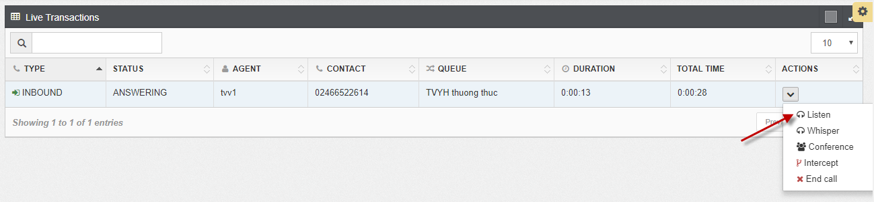

* The call is ringing to supervisor’s webphone.
* The supervisor picks up phone:
  + The supervisor can hear what the agent and the customer said.
  + The customer and the agent cannot hear what the supervisor said.

#### Whisper

* The Function allows a supervisor to whisper to an agent when there is an Inbound, Outbound call taking place between the agent and a Customer. At that time, only the agent could hear the supervisor, the customer did not hear.
* On “Transaction monitoring” screen, click Action column, choose **“Whisper”:**

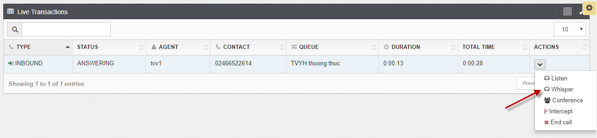

* The call is ringing to webphone’s supervisor:
  + The agent could hear what the supervisor said
  + The customer hear what the agents said, could not hear the supervisor
  + The supervisor hear all the agent and the customer.

#### Intercept a call

* + The Function allows a supervisor to rob an inbound or outbound call taking place between an agent and a customer. At that time, the agent was dropped out of the conversation, completely transferred to the supervisor.
* On *“Transaction monitor” screen* – Click Action column – choose **“Intercept”**

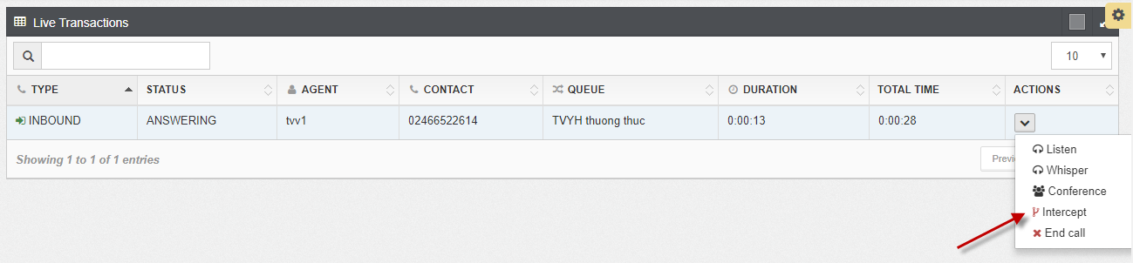

* Then:
  + On the supervisor’s screen: the call is ringing. The supervisor pick up phone to talk with the customer.
  + On the agent’s screen: there is one message: A supervisor has interrupted the call, you need to hang up phone.

#### End a call

* The Function allows a supervisor to end an inbound or outbound call taking place between an agent and a customer.
* On *“Transaction monitor” screen* – Click Action column – choose **“End call”.**

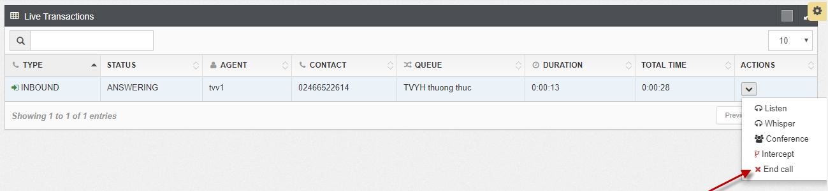

* Then, the call is ended.

# APPENDIX

## Appendix 1: Notes when you login AgentWeb on first time.

* If it is the first time the Agent logs into the AgentWeb: the system will ask whether it is allowed to display the notification and to use the microphone. gent needs to confirm agree to receive Notification and use the mic to make a call.

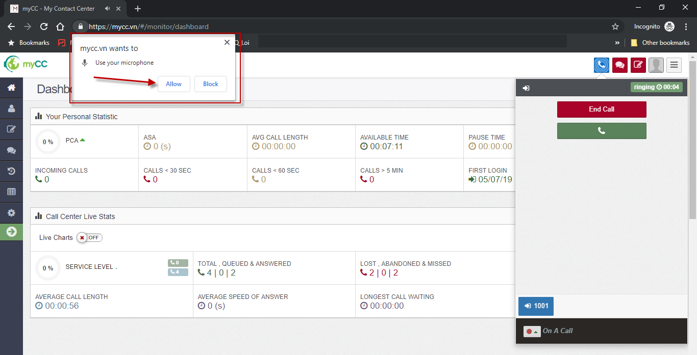

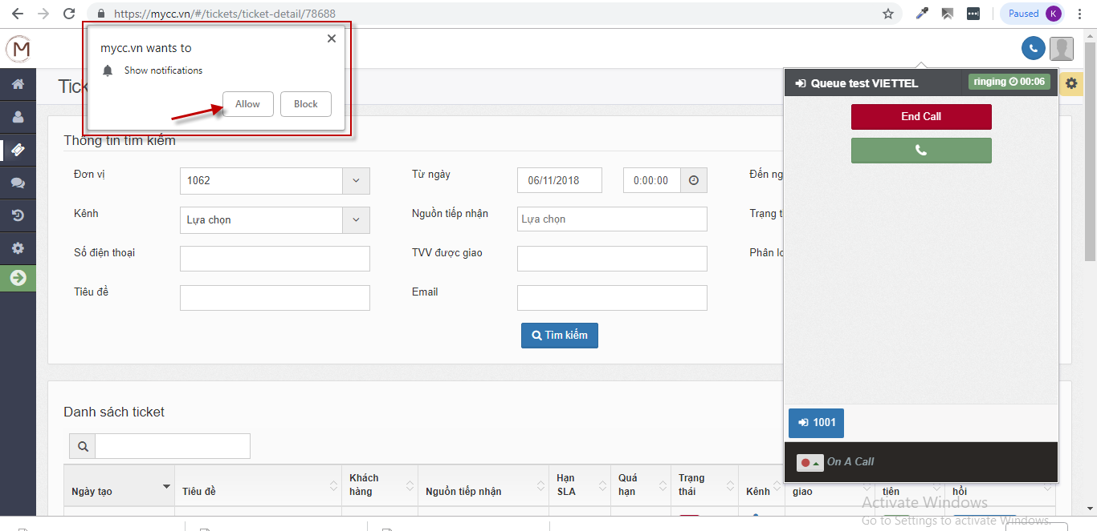

## Appendix 2: Actions need to be performed each time there is a new version.

* Delete cache of the browser.
* Press Ctrl F5: (exp: <https://cbcc.ddns.net:9090>)
* Login again.